2002/2003 AIAA
Cessna/ONR Student Design/Build/Fly Competition
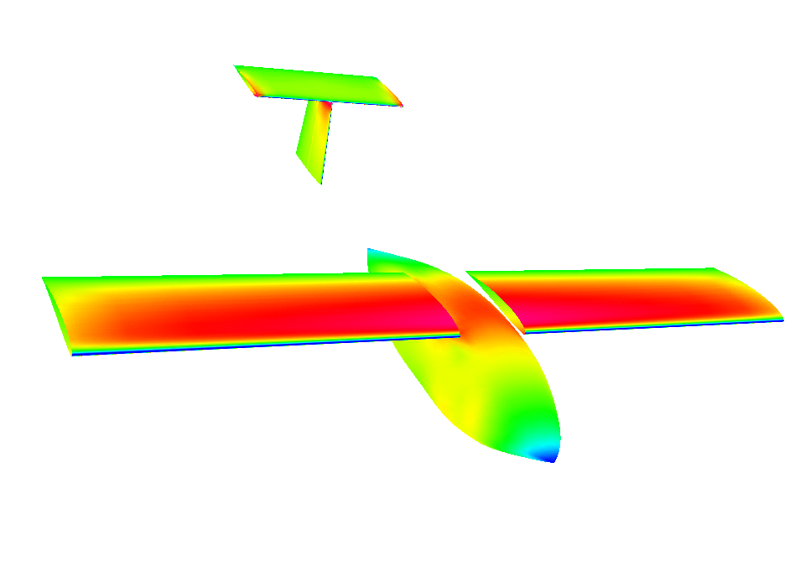

San Diego State University

Spirit of Monty
Table of Contents
1. Executive Summary 1
1.1. Conceptual Design 1
1.2. Preliminary Design 2
1.3. Detail Design 3
2. Management Summary 4
2.1. Architecture and Responsibilities of the Team 4
2.2. Schedule Control 6
3. Conceptual Design 8
3.1. Problem Statement 8
3.2. Assumptions 9
3.3. Trade-offs Between Mission Flights 14
3.4. Design Considerations 15
3.5. Conclusion of Conceptual Design Phase 22
4. Preliminary Design 23
4.1. Configuration Basics 23
4.2. Assembly System 24
4.3. Wings 25
4.4. Fuselage 30
4.5. Tail Options and Sizing 32
4.6. VSAERO Configurations Tested 33
4.7. Wing-Body Lift Curve 35
4.8. Drag Estimation 35
4.9. Power Plant Design 36
4.10. Structural Considerations 37
5. Detailed Design 38
5.1. Configuration Summary 38
5.2. Rated Aircraft Cost 39
5.3. Dynamic Stability Estimation 39
6. Manufacturing Plan 46
6.1. Major Components 46
6.2. Materials 46
6.3. Figures of Merit 46
6.4. Summary of Material Choices 47
6.5. Manufacturing Schedule 48
6.6. Manufacturing Processes 50
6.7. Electronic Components and Payload Deployment System 52
6.8. Structural Integrity 52
6.9. Conclusion of Fabrication Phase 52
7. Testing Plan 53
7.1. Flight Testing Objectives and Checklist 53
7.2. Lessons Learned 54

Executive Summary
The following summarizes the development of “Spirit of Monty”, an entry from San Diego State University into the Cessna/ONR Student Design/Build/Fly Competition at St. Inigos, Maryland, on 25-27 April 2003. The competition requires that the students design, fabricate, and demonstrate the airplane that best satisfies the required missions. Three different missions are specified, but only two of the three need to be performed. Depending on the mission there are different types of payloads and flight requirements. The goal is to maximize the Total Score, which is accomplished by scoring the best in three areas. One area is to maximize the flight performance of the aircraft and thereby maximizing the Total Flight Score. Another is to achieve the lowest virtual cost of the airplane called the Rated Aircraft Cost (RAC). Finally, the Report Score must be maximized by well documenting the design, fabrication, and testing process. To accomplish this mission, the team “Spirit of Monty” began its exploration from the conceptual design.

Conceptual Design
First, the problem statement of the competition was made so that the following assessments would be well targeted. Before investigating alternative designs, some assumptions were made according to calculations as well as to the results from last year’s competition entry. These assumptions were necessary to determine the core characteristics of the aircraft such as the minimum planform area and the estimated weight. Next, competition requirements, including a choice of three different missions, were assessed in order to create design parameters for each conceptual design consideration. Evaluating alternative designs of the aircraft with the parameters, conceptual design phase led to one configuration for each of five design considerations, with maximum scoring potentials.

Conceptual Design Considerations
Design considerations included the basic aircraft configuration, payload system, wing configuration, type of the landing gear, and assembly systems. Basic aircraft configurations were discussed such as the conventional with T-tail, conventional with V-tail, conventional with twin-boom, canard, flying-wing, and bi-plane. Concepts for the payload system consisted of a vertical-drop, roll-aft, and roll-front. High-, mid-, and low-wing configurations were evaluated for structural and stability aspects. Type of landing gear resulted in one version without competing concepts. Lastly, effective assembly of the aircraft was examined. Alternative designs for each of these five considerations were evaluated by using the design tools.

Conceptual Design Tools
Design tools included visualization tools, calculation tools, and design parameters that worked in the process of calculations. To visualize alternative designs, Pro-Engineer (CAD) was used to create 3-dimensional images. Excel spreadsheets were one of the main calculation tools, providing a qualitative analysis with embedded programs that were constructed by the team. Design parameters were called Figures of Merit (FOM). FOM are the factors that would either directly or indirectly affect the scoring potential of the aircraft. Effects of the direct factors, such as RAC, were calculated by the spreadsheet, while effects of the indirect factors were interpreted qualitatively to give the numerical value of the scoring potentials of each alternative design.

Results of the Conceptual Design Phase
The first two of the three specified missions, Mission A and B, were selected for further design because of their scoring potential. Spirit of Monty would be a conventional T-tail (or V-tail) plane with high-wings and a tractor-propeller. Payload would be vertically dropped during Mission B, while the cylinder for Mission A would hang below the fuselage. Wings would be split into two parts in order to fit in the assembly box and the landing gears would be a tricycle configuration: one nose and one on either side of the fuselage. An assembly process was also conceived to allow for a rapid assembly time.

Preliminary Design
To begin with, schematic drawings of the assembly components of the aircraft were made and were placed in a drawing of the storage box to find a suitable position. This was the foundation to designing the assembly mechanisms. The next step was the determination of the wing design, since it would define the upper surface of the fuselage. Airfoil, planform area, wingspan, and chord length optimization was performed. Using the upper surface of the chosen airfoil (SD7043), the outer mold line of the fuselage came next, followed by the analyses on the tail configurations. Drag and stability of the chosen configuration were evaluated. Power plant and structural analyses were also was performed.

Preliminary Design Considerations
Several assembly methods were considered for each component, from which a concept with the quickest connections was selected. Design considerations for the wing consisted of three different airfoils, including the one from Monty’s Revenge, last year’s airplane. The fuselage design had two competing concepts concentrating on the trailing edge style. Tail considerations focused on the comparison between T-tail and V-tail. Power plant was designed from different combinations of motors and propellers.

Preliminary Design Tools
Airfoil choice began by researching various airfoils and utilizing the 2-D viscous solver X-FOIL for airfoil optimization. Graphs of C_{l} vs. α and C_{d} vs. C_{l} of different airfoils were used to determine which was best for the mission. Planform area, wingspan, and chord length were determined by designing an Excel spreadsheet, which allowed comparison of RAC values for different combinations. For the fuselage design, X-FOIL was used to create the lowest drag-configuration, and Pro-Engineer (CAD) was used to model it into a 3-D shape. VSAERO, an inviscid 3-D solver, was used to integrate the fuselage, wing, and tail configurations to predict the performance. Lift and drag were numerically calculated and compared with the computer data. MotoCalc and P-calc, two electric power plant optimization programs, were used to design the power plant configuration.

Results of the Preliminary Design Phase
Final decisions were made on the assembly methods and the configurations of the wings, fuselage, and tail. Component optimization was now complete and estimation of the performance gave satisfactory results to proceed into the detail design.

Detail Design
The final design was created which included detailed drawings of the major and minor components. Component selection and system layout was also completed. Final Rated Aircraft Cost was determined, which was lower than originally predicted during the early design phase. Performance evaluation, including dynamic stability, was performed to determine if any modifications would be necessary.

Detailed Design Considerations
Since the sizing had been performed and all other specifications of the design are known, the stability and detailed weight tracking were now the focus. Battery placement and the actual weight of the composite materials were only estimated during the previous design phases. To ensure a balanced aircraft a team member was assigned the Mass Properties position to keep track of weights and locations.

Detailed Design Tools
Dynamic stability performance was evaluated by utilizing many sources. Advanced Aircraft Analysis (AAA), a computer aircraft design tool was used to evaluate the stability. Used in conjunction with AAA much of the stability calculations were performed by hand. For that to be accomplished, Pro-Engineer was used to obtain the moments of inertia and other needed measurements. Other performance was recalculated such as take-off distance and maximum rate of climb to compare with the earlier estimations.
Pro-Engineer was the most used tool during the final design phase. Codes were obtained to operate the CNC mill in order to machine the fuselage foam cores. Pro-Engineer was also used to create drawings from the models in order for the Manufacturing Team to build the major components.

Results of the Detailed Design Phase
The final design showed that the extensive work during the Conceptual and Preliminary Design phases benefited the project. The airplane was evaluated to be stable using two separate methods. Take-off distances and other performance characteristics were very close to design parameters
Machining of the foam cores saved the Manufacturing team many hours of shaping it by hand. The team was handed the drawings to begin the fabrication process.

Management Summary
Design work started with only five members, who participated in last year’s competition. The five gathered in August, after the release of a draft of the 2002/2003 Competition Rules. Greg Marien, the Project Manager, would continue to lead the team, and assigned an Assistant Project Manager and some of the team leaders. As the AIAA Student Chapter at San Diego State University grew dramatically in Fall 2002, the team was able to add members to each design group. Assignment areas for each member depended on both skills and wishes. Ultimately, the team was composed of 1 faculty advisor, 1 graduate student, 12 seniors, 10 juniors, and 5 freshmen.

Architecture and Responsibilities of the Team
As Figure 2-1 below illustrates the architecture of the team followed by the description of the positions.
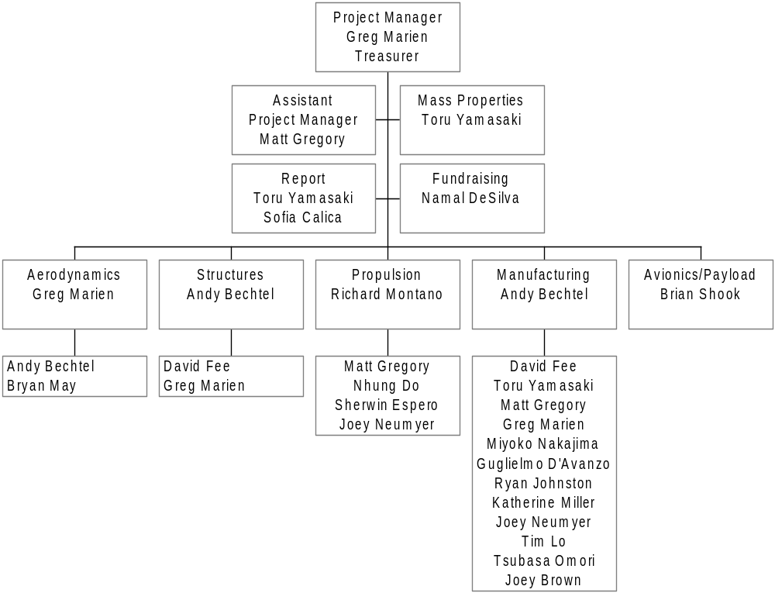
Figure 2-1 Team Architecture

Project Manager
The Project Manager calls the meetings and is responsible for schedule management. Leading the fundraising presentations and approving the budget are also the Project Manager’s responsibilities. Important decisions made by the design teams need to obtain recognition from the manager.

Assistant Project Manager
This position was created to train a new Project Manager for the following year. Appointed to the position was a junior member on his second year of Design/Build/Fly participation. The assistant is to be involved with all the aspects of the Project Manager’s duties to ensure the transfer of knowledge.

Treasurer
The Project Manager also serves as the AIAA Student Branch Treasurer, so the positions were combined. The treasurer is responsible for the registration of all donors and donations given to the team. The Team Leaders should obtain permission for necessary purchases from the treasurer for reimbursement.

Team Leaders
Responsibilities include organizing each team by assigning duties to individual members, and to report to the Project Manager the status of the group’s tasks.

Fundraising
This team organizes fundraising events and presentations. The events include several BBQ’s and lunch meetings with permission from the school, and an exposition featuring Monty’s Revenge from last year. Also, letters have been sent to alumni, asking for monetary and/or equipment donations. Corporate funding was also received from Northrop-Grumman.

Aerodynamics
This team is responsible for analyzing and aerodynamically optimizing the fuselage, wing, and tail configurations. They are also responsible for stability evaluation.

Power Plant
This team is responsible for wind-tunnel tests on several motor-propeller combinations. Research on the other equipment including batteries is also the responsibility of the group.

Avionics/Payload
This team is responsible for the electrical wiring within the aircraft. The focus is on the security and effectiveness of the connections between assembled parts of the aircraft, as well as the payload interface system.

Structure and Fabrication
This team is responsible for submitting a feasible fabrication plan that met both the budget and skills of the team. Then, the group fabricates the aircraft based on the drawings from the drawing team. Structural analysis and logistics are also assigned to this group.

Drawing
This team is responsible for converting the alternative designs and the final configuration into CAD parts and drawings. This job was a group effort between the Aerodynamics, Structures, and Manufacturing teams.

Report
The Report Team collects the data from the research and development, and compiles it into the final report. The group also provides some design parameters to the other teams, in accordance with the design report requirements from the competition rules.

Schedule Control
An original milestone plan was made at the first meeting of the team. Table 2-1 on the following page illustrates the comparison between the original plan and actual design processes. Weekly meetings of the Team Leaders along with the Project Manager helped manage the schedule of the design phases. Any changes to the schedule had to be addressed at the weekly meetings and approved by the Project Manager.

Conceptual Design
The conceptual design phase was an investigation of the mission requirements and design considerations, which created the best path to the most competitive design. Alternative designs in each concept competed towards a maximum scoring potential. Design considerations included basic aircraft configuration, payload system, wing configuration, landing gear type, and assembly of the aircraft. For each of the considerations, the best concept was chosen. The remaining structure, shape, sizing, and power plant were evaluated in the preliminary and detail design phases.

Problem Statement
Total Score of the competition incorporates Total Flight Score, Rated Aircraft Cost (RAC), and Report Score such that:
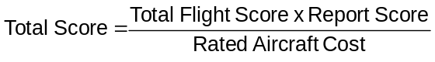
Equation 3-1 Total Score
Report Score was held at 90 (average competition report score) throughout the report for simplicity. Therefore, the conceptual design phase would focus on how Total Flight Score and RAC affect Total Score as they change with respect to alternative design configurations. Following the design analyses, alternatives that offer maximum scoring possibility against the specified missions were selected.
As illustrated in Figure 3-1, the missions would be flown on a specified course to compete toward Total Flight Score.
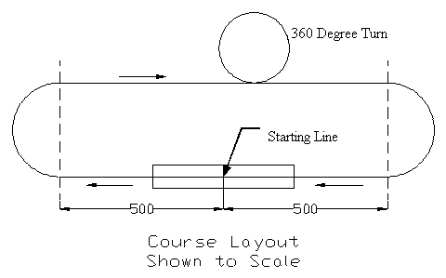
Figure 3-2 Course Description; distances are in feet (reproduced from competition rules)
Total Flight Score is calculated by summing the best Single Flight Score (see Equation 3-2) from two of the three missions, A, B, or C. Each of the missions has a numerical difficulty factor of 2.0, 1.5, and 1.0, respectively. Table 3-1 below briefly summarizes the profiles of these missions broken down into its component parts.
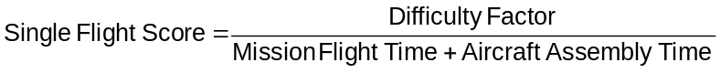
Equation 3-2 Single Flight Score

Mission | A | B | C
Difficulty Factor | 2.0 | 1.5 | 1.0
Total Laps | 4 | 4 | 4
# of 180º turns/lap | 2 | 2 | 2
Total # of 180º turns | 8 | 8 | 8
# of 360º turns/lap | 1 | 1 | 3
Total # of 360º turns | 4 | 4 | 12
Payload | 5lb 6"x6"x12" box | 5lb 6"x6"x12" box | 5lb 6"x6"x12" box
Particular Task | A simulated cylindrical antenna, a section of unmodified 6" PVC pipe 3" tall | Landing and remote deployment of payload after 2 laps
Table 3-1 Mission Summary
Mission Flight Time is the total time between a “go” signal from the official and the aircraft’s complete stop past the starting line after finishing a mission. Included in the Single Flight Score is a timed assembly task, which must be performed at least once before the first attempted mission. Prior to the assembly task, the disassembled aircraft must fit in to a 2’ X 1’ X 4’ (inner dimension) box. Three team members are timed on the assembly of the aircraft to make it flight-ready. The wing tip lift test and control system function/orientation test are then performed with a 3-minute penalty added to Aircraft Assembly Time for each incorrect operation. This makes the quickness and reliability of assembly an important design parameter.

Assumptions
Assumptions depended both on calculations and on the data from Monty’s Revenge, last year’s competition entry. The estimated parameters included the empty/loaded weight, cruising speed, weather conditions, Assembly Time, and RAC. These assumptions were necessary to obtain an estimate of the Total Score on which the design would be based.

Estimated Take-off Weight
Empty weight of the aircraft was set to 12 pounds. This estimation was based upon previous years of fabrication experience. Last year’s entry had a 20 pound empty weight and since there is a 4 pound reduction in payload the weight was set to 16 pounds. Furthermore, a reduction in 4 more pounds is achieved from the improved experience in a lighter weight structure and a lighter weight power plant. Therefore, the empty weight was set to 12 pounds and a maximum take-off weight of 18 pounds (5 pounds for box and 1 pound for cylinder).
 | lb
Empty weight from last year | 20
Payload reduction | 4
Structure reduction | 4
Estimated empty weight | 12
Box payload | 5
Cylinder payload | 1
Maximum take-off weight | 18
Table 3-2 Estimated Take-off Weight Summary

Estimated Cruising speed
Baseline speed of 100ft/s was used, which was the same speed as last year’s competition entry. This speed is only used for initial sizing calculations and estimating flight scores. Further evaluation of the speed is performed in the preliminary design phase. Because this year’s design is lighter and more research was to be performed on the power plant, speed was raised to 120 ft/s with the payload box, while the cylinder payload remained at 100 ft/s. The reduction in speed is based on a calculated 2 pounds of cylinder drag from empirical data (Reference 5).

Weather conditions
Historical weather conditions from www.weatherbase.com were used for design considerations. A worst-case scenario of a low atmospheric pressure and a high temperature was used to ensure adequate performance in extreme conditions, shown in Table 3-3 below.

Initial Wing Sizing
Initial wing sizing was based on weather conditions, estimated take-off weight, cruising speed, turn performance and take-off distance (<120 ft). Evaluating different families of possible airfoils (low drag/high lift), a C_{lmax} of 1.6 was used for estimations.

Temperature (T) | 100 | F
Pressure (P) | 28.75 | in Hg | Loaded weight (W) | 18.00 | lb
Density (ρ) | 0.00212 | slugs/ft³ | Average velocity (V) | 100 | ft/s
Viscosity (μ) | 3.97E-07 | lb-s/ft² | Takeoff velocity (V) | 50 | ft/s
Kinematic viscosity (ν) | 0.00019 | ft²/s | Dynamic pressure (q) | 10.59 | lb/ft²
Table 3-3 Sizing parameter assumptions
Table 3-4 below shows the results of the initial sizing of the wing using the assumptions from Table 3-3 above. The limiting factor was the 4.5-g turn performance; therefore the planform area was set to 5.5 ft²

Turns | g-loading | 4.5
Turns | φ (bank angle) | 77.16 | degrees
Turns | Turn radius | 71.23 | ft
Turns | Required planform area | 5.50 | ft²
Cruise | Required planform area | 3.40 | ft²
Take off | Required planform area | 4.86 | ft²
Table 3-4 Planform area requirement to meet the mission

Rated Aircraft Cost (RAC)
The initial working concept must be designed to reduce the RAC as much as possible for the maximum Total Score. There is a limit to the amount of reduction since the concept must still be a stable and flyable design. The following RAC equation is used to simplify the theoretical cost of each team’s airplane.
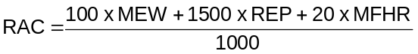
Equation 3-3 Rated Aircraft Cost Calculation
Where:
MEW = Manufacturers Empty Weight
REP = Rated Engine Power
MFHR = Manufacturing Man Hours

Table 3-5 below shows a breakdown of the RAC for one conceptual concept.
 | RAC | 8.71
 | MEW | 12.00
 | REP | 2.84
 | MFHR | 163
# of cells | 24 |  | Sanyo 1700 SCR
weight per cell | 1.89 | oz | weight includes extra hardware
total battery weight | 2.84 | lb
WBS | Value | Hours | Multiplier
1.0 Wings
wing span (ft) | 5.50 | 44 | 8 hr/ft Wing Span
chord (ft) | 1.00 | 8 | 8 hr/ft Max chord
# of control surf | 2 | 6 | 3 hr/control surface
2.0 Fuselage
Max length (ft) | 5 | 50 | 10 hr/ft max length
3.0 Empennage
# of vertical-nc | 0 | 0 | 5hr/vertical-no control
# of vertical-ac | 0 | 0 | 10 hr/vertical-active control
# of horizontal | 0 | 0 | 10 hr/horizontal-see wing rule
V-tail only |  | 15 | v-tail-15 hr
4.0 Flight Systems
# of servos/control | 6 | 30 | 5 hr/servo (Note 1)
5.0 Propulsion
#of engines | 1 | 5 | 5 hr/engine
#of propellers | 1 | 5 | 5 hr/propeller
Note 1: 2 ailerons, 2 stabilizer, 1 nose wheel, 1 payload release
Table 3-5 RAC Calculation

Propulsion Configuration
Early in the conceptual phase, use of an Excel spreadsheet shown in Table 3-5 above allowed the removal of a two-motor concept. Using only one motor reduced the RAC by almost 15%, which is significant enough to affect the Total Score.
Using a tractor configuration instead of a pusher was decided early on due to the interference of the pusher propeller and the released payload during Mission B.

Landing Gear Configuration
Landing gear configuration had two options, tricycle or a tail wheel. First, the released payload would interfere with the tail wheel during the take-off. Second, if the payload release concept was to drop from the fuselage then the payload should be parallel to the ground for ease of deployment. Therefore, the tricycle landing gear was chosen.

Assembly Time
Another assumption was that for the assembly task each step would take 10 seconds; for example, it took roughly 10 seconds to assemble the wings of last year’s competition entry, which had a plug-in type design. Three personnel are allowed on the assembly team and therefore up to three steps could be done simultaneously. For example, the time of assembly would be 10 seconds for three parallel tasks. The tasks considered were, assembly of the landing gear, connection of the wing parts, connection of the tail, and connection of the wing to the fuselage. The first three steps would be done in parallel while one person would perform the final step. Total Assembly Time by this estimation is 20 seconds, but 10 more seconds were added for the unforeseen circumstances factor. The final estimated Assembly Time was set to 30 seconds. Further sizing and configuration will reduce this time to a minimum.

Estimated Total Score
Total Score predications were made based on the three types of missions using the assumed flight speeds and estimated RAC. Results are in Tables 3-6 through 3-9 below.
Mission A | 4 laps/ 8-180º turns/ 4-360º turns
1 lap | distance (ft) | velocity (ft/s) | time of flight (s)
Straight cruise | 2000 | 100 | 20.00
2-180º turns | 157 | 80 | 1.96
1-360º turn | 157 | 80 | 1.96
Total distance (4 laps) | 9256 |  | 95.70
 | Flight Time (min) | 1.60
 | Single Flight Score | 0.95
Table 3-6 Mission A Estimated Flight Performance
Mission B | 4 laps/ 8-180º turns/ 4-360º turns /one landing
1 lap | distance (ft) | velocity (ft/s) | time of flight (s)
Straight cruise | 2000 | 120 | 16.67
2-180º turns | 157 | 100 | 1.57
1-360º turn | 157 | 100 | 1.57
Landing |  |  | 30.00
Total distance (4 laps) | 9256 |  | 109.23
 | Flight Time (min) | 1.82
 | Single Flight Score | 0.65
Table 3-7 Mission B Estimated Flight Performance
Mission C | 4 laps/4 turns/4-360's
1 lap | distance (ft) | velocity (ft/s) | time of flight (s)
Straight | 2000 | 120 | 16.67
2-180º turns | 157 | 100 | 1.57
3-360º turn | 471 | 100 | 4.71
Total distance (4 laps) | 10512 |  | 91.79
 | Flight Time (min) | 1.53
 | Single Flight Score | 0.49
Table 3-8 Mission C Estimated Flight Performance
Aircraft assembly time | 30 seconds | 0.50 minutes
Mission | A&B | A&C | B&C
Report Score | 90 | 90 | 90
Total Flight Score | 1.60 | 1.45 | 1.14
RAC | 8.71 | 8.71 | 8.71
Total Score | 16.54 | 14.95 | 11.77
Table 3-9 Estimated Total Flight Score
Initial observation shows the best strategy for obtaining the highest Total Score is to design around Mission A and B. But, changing the design to fit only specific missions may improve RAC enough to justify a reduced difficulty flight routine. The next section deals with this exact concern.

Trade-offs Between Mission Flights
A trade study was performed on whether neglecting Mission B can result in a higher Total Score. Exclusion of Mission B meant an improved RAC due to one less servo, since there would be no payload deployment, and subsequently less weight for the release mechanism. Assembly Time was assumed to not improve, since it is not related with deploying of the payload. Cruising speed may increase by a small amount due to weight reduction.
Figure 3-2 shows how the combination of Mission A & C compares to that of Mission A & B. Even if the aircraft acquires 10ft/s more cruising speed in the first combination, it is apparent that for Missions A & C to beat the Total Score of A & B, a 0.3 decrease in RAC is needed. However, one less servo contributes to only a 0.1 decrease, and negligible weight decrease, which is only 1/3 of what is needed. Hence it is concluded that Mission B is to be accomplished. Mission B & C scoring would be so low that the design would no longer be competitive. The conclusion is to design around Mission A and B; Mission C will still be able to be flown if needed by designing around Missions A & B.
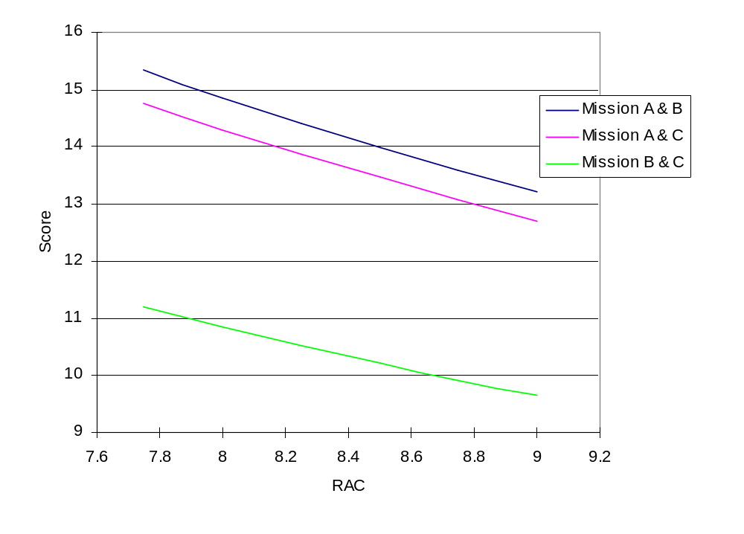
Figure 3-3 Comparison of Total Points for Different Missions

Design Considerations
Five different areas were considered in the conceptual design phase. The following is a list of the design areas along with the reasons why it was felt necessary to discuss them.
- Basic Aircraft Configuration: The most fundamental characteristics of the aircraft were decided at the beginning. This decision induced restrictions on the other aspects of the design.
- Payload System: Method of deployment affects both internal and external structure of the aircraft, especially that of the fuselage. For instance, if the payload would roll aft for deployment, structure would be required at and around the opening of the fuselage. Landing gear interference was another concern. Along with the payload deployment system is the simulated antenna, which must be mounted externally at least 3” away from the airplane’s structure. The location of the antenna must also be in the air stream with no obstructions (not including the tail and the landing gear).
- Wing Configuration: High-, mid-, and low-wing configurations were discussed. While the natural tendency was to choose a high-wing for a cargo plane, the discussion justified the choice. This concept led to detailed assembly methods and fuselage structure, as well as restrictions on landing gear locations.
- Type of Landing Gear: Since the payload deployment system had to be finalized before choosing the landing gear configuration, there were few considerations. A tricycle configuration was already decided upon, nevertheless, the landing gear configuration led to further exploration in the conceptual design phase for rapid assembly.
- Assembly Systems: Several assembly methods were evaluated for the wings, tail, and landing gear. Reducing the number of parts needed to be assembled and simplifying the way the parts are assembled shortens the time of assembly.
For each design consideration, design parameters are defined as Figures of Merit (FOM), which include Rated Aircraft Cost (RAC). FOM, which vary from one design consideration to another, are the parameters that affect scoring potential. One example of FOM is stability, because poor stability can prevent a design from being competitive. A definition and calculation of RAC is summarized in Section 3.2.5 above.
FOM, which cannot affect Total Score numerically, are rated individually. The ratings range from -0.2 to +0.2 with an increment of 0.1; 0 represents normal. The reason for the small values of the ratings is that the ratio of change to the Total Score has to be small in order to emphasize the significance of its effect. An Effective Score is then calculated by summing Total Score with the sum of the FOM. Effective Score is a numerical equivalent to the potential scoring capability of the design.

Equation 3-4 Effective Score Calculation

Basic Aircraft Configuration
Basic designs of the fuselage, wing, and tail were determined during this step. Each configuration with the highest Effective Score was carried through to the next design consideration. Basic aircraft configuration was evaluated using the following Figures of Merit:
- RAC: a numerical value was calculated accordingly.
- Ease of Assembly: each advantage or disadvantage was accounted for by a difference in Assembly Time.
- Drag Performance: increasing or decreasing the cruising speed by 10 ft/s accounted for each predicted increase or decrease in drag.
- Take-Off and Landing Performance: 3 seconds were either added or subtracted for an advantage or disadvantage in the performance.
- Flight Performance: Flight performance including stability and control is a significant factor since it affects the ability to complete the missions.
- Experience: The team’s ability to design a competitive aircraft affects all design configurations. If the experience does not exist, this could affect the overall competition outcome.
One (I) through four (IV) above were first numerically evaluated for Total Score. FOM V and VI were then used to evaluate six alternative configurations. An Effective Score was calculated to allow a decision to be made of not only the best design, but to help the team decide which one could be more easily fabricated. Summary of the evaluations are in Table 3-10 below. Pictures of the conceptual configurations are in Figure 3-3.
- Conventional with T-tail: A Total Score of 14.26 set the standard for other configurations. Rating for both FOM V and VI was 0.2 because this was the configuration in which the team had the most experience. Effective Score is 14.46.
- Conventional with V-tail: RAC decreased by 0.1 for the V-tail compared to the T-tail. This change made Total Score 14.75. FOM V dropped to –0.1 because the V-tail has effective area losses and therefore requires a bigger tail to attain the same stability and control. This results in a possible increase in RAC due to the 25% contest rule with the tail versus the wingspan. FOM VI dropped to –0.2 because of the lack of v-tail design experience. Resultant Effective Score is 14.45.
- Conventional with twin boom/H-tail: H-tail increases RAC by 0.1 and an additional boom weighs roughly 0.25 lb more increasing RAC by 0.02. Alignment of two tail booms during assembly is more complicated than one boom; therefore, Assembly Time is increased by 3 seconds to accommodate this resulting in a Total Score of 14.12. Two-boom support gave an improved stability due to the more rigid tail structure resulting in a FOM V of 0.1. Less experience with this design results in a -0.1 rating. The result is an Effective Score of 14.12.
- Canard: First three Figures of Merit were evaluated as the same as conventional because the only fundamental difference between a canard and conventional is the location of the wings and horizontal stabilizers. The result is a Total Score of 13.96. Better stall performance of the canard made the rating of stability 0.1, and since the team has no experience with canard, FOM VI is set to –0.2. Effective Score is 13.86.
- Flying wing: RAC decreased by 0.3 due to removed tail weight and control surfaces. Assembly Time also improved by 3 seconds for not having to assemble the tail. Worse take-off and landing performance added 3 seconds per event. Calculated Total Score is 14.72. Marginal stability of the flying wing resulted in a stability rating of -0.2. Experience was moderately lacking resulting in a rating of -0.1. Effective Score is 14.42.
- Bi-wing: Since layering the wings would require a 6-inch longer combined wingspan due to lower aspect ratios, RAC increased by 0.08. It might be possible to shorten Assembly Time by 3 seconds, assuming that two wings would be attached and fit in the box (1-foot box height), but the wings would also be too close together for proper airflow, which reduces lift. Calculated Total Score is 14.82. Parasitic drag is also a common problem with a bi-wing design. Lack of experience is also a factor, thus ratings for the last two FOM are both -0.2. Effective Score is 14.42.

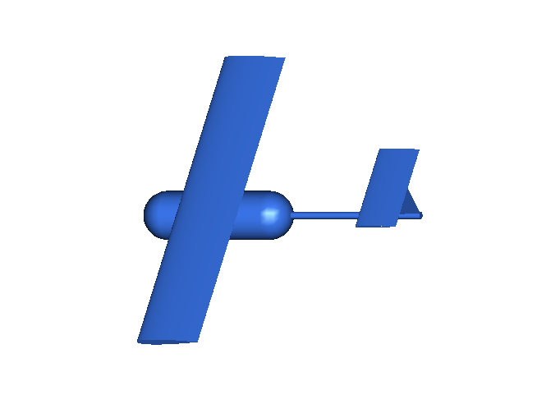 | 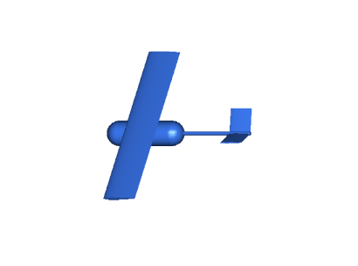
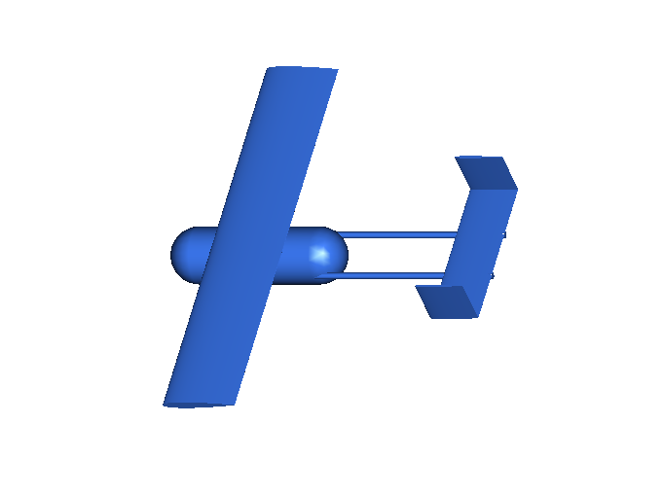 | 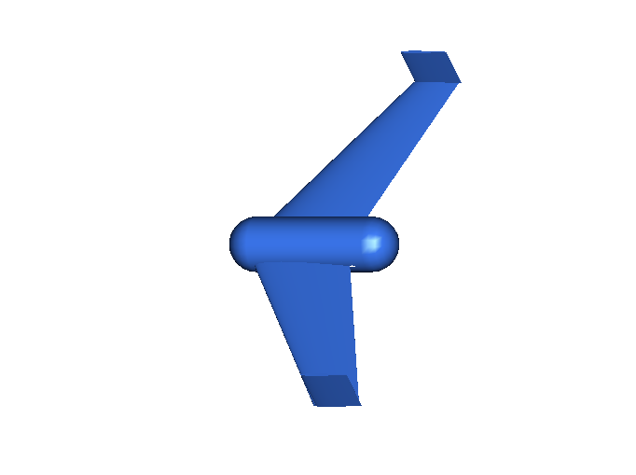
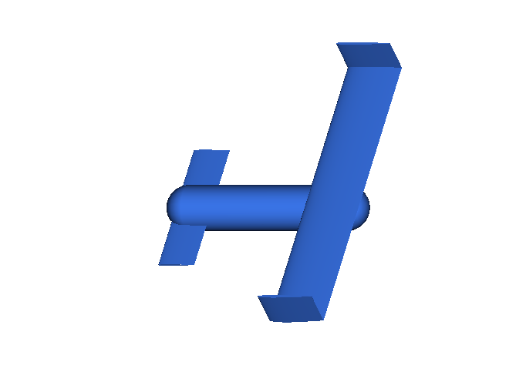 | 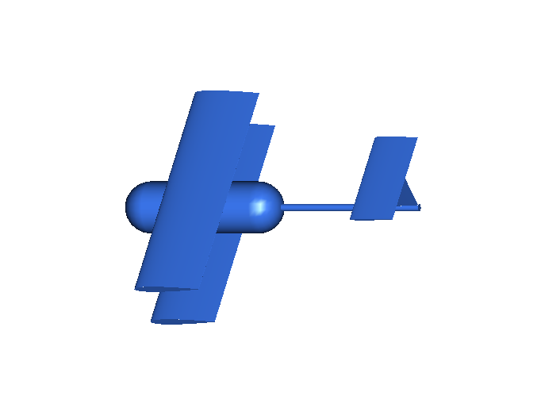
Figure 3-4 Conceptual Configurations

 |  | FOM Ratings
Configurations | Total Score  FOM I-IV | V | VI | Effective Score
Conventional w/T-tail | 14.26 | 0.2 | 0.2 | 14.46
Conventional w/V-tail | 14.75 | -0.1 | -0.2 | 14.45
Conventional w/H-tail | 14.12 | 0.1 | -0.1 | 14.39
Canard | 13.96 | 0.1 | -0.2 | 13.86
Flying Wing | 14.72 | -0.2 | -0.1 | 14.42
Bi-plane | 14.82 | -0.2 | -0.2 | 14.42
Table 3-10 Configuration Summary
Conventional configuration with T-tail was chosen over the other configurations. The choice was reasonable in the sense that this configuration was balanced in potential Total Score, stability & control, and experience. Because the V-tail configuration also scored high, both designs would be further evaluated in the preliminary design.

Payload System
Remote deployment of the payload is critical to Mission B. The concepts that were presented and discussed include vertical drop, roll-front, and roll-aft. Figures of Merit (FOM) for the system are the following:
- Total Score: This contains estimated flight time, RAC, time of assembly, and drag performance of the components. Values were calculated in the same manner as Table 3-5.
- Landing Gear Interference: Deployed payload should not interfere with the landing gear to ensure the second take-off during Mission B.
- Complication: Complication of the mechanism results in an increase in weight and/or payload deployment reliability problems.
Summary of the evaluation is in Table 3-11 below.
- Vertical Drop: To set a standard, FOM III has rating of 0. The landing gear interference is not anticipated for this concept because the payload would be on the ground between the main gears; therefore, FOM II rating is set at +0.2. Total Score is 14.43, and Effective Score is 14.63.
- Roll-front: Rolling would increase deployment time by at least 3 seconds because a mechanism would be needed to help the deployment instead of using gravity. Necessary space in the fuselage for the rolling would make the body longer by about 3”, which increases the weight and therefore increasing the RAC by an estimated 0.05. Total Score is now 14.22. Landing gear might be an interference problem since the deployed payload would be in front of them. A complicated mechanism would also be required to roll the payload while keeping the surface of the fuselage in the same shape after deployment (faired payload doors). Therefore, each FOM was assigned a –0.1 rating. Effective Score became 14.02.
- Roll-aft: In this concept, a longer fuselage was unnecessary because the edge of the payload might be exposed at the back end of the body. However, this increases drag during flights, which would decrease cruising speed by 10ft/s. Total Score calculated is 13.98. Rolling-aft would not interfere with the landing gear, so the rating was 0.2. Mechanism may be as simple as the vertical drop; therefore, the FOM III is set to 0. Effective Score becomes 14.18.
 |  | Ratings of FOM
Alternatives | Total Score  FOM I | II | III | Effective Score
Vertical Drop | 14.43 | 0.2 | 0.0 | 14.63
Roll-front | 14.22 | -0.1 | -0.1 | 14.02
Roll-aft | 13.98 | 0.2 | 0.0 | 14.18
Table 3-11 Summary of Payload Release Configuration
The decision process showed that the vertical drop has significant advantage in the Total Score; therefore, vertical drop is the winning concept.
There are two locations to mount the antenna, above the airplane or below the airplane. Above the airplane may cause instability due to an upward shift of the CG. Also, the concern of the wake interfering with tail surfaces prompted the decision for mounting the cylinder under the fuselage.

Wing Configuration
Before a landing gear design or assembly method could be created, wing location had to be determined. Keeping assembly times constant, high-, mid-, and low-wing configurations were evaluated for the following considerations:
- Weight: This FOM was considered since it affects Total Score due to the structural weight. Increased weight of the vehicle results in a higher RAC and slower flight speeds, which reduce Total Score.
- Landing Gear Interface: Mounting location of the landing gear will be affected by wing location. Normal mounting location beneath the fuselage has been removed from consideration because of the payload deployment method.
- Stability: This quantifies the ability of the aircraft to complete the mission flights.
Evaluation of the alternatives is as follows; a summary is in Table 3-12 below:
  - High-wing: For high-wing, it is possible to mount the wing on top of the fuselage in which a through-type structure could be attached to the fuselage. Because of the reduced weight, Total Score result is 14.75. Disadvantage of the high-wing is that a retractable landing gear system would not be able to be deployed from it; therefore, a FOM II rating of –0.2 was assigned. On the other hand, a high-wing allows for good roll stability resulting in an assigned FOM III rating of 0.2. Effective Score becomes 14.75.
  - Mid-wing: Total Score is 14.43. It is lower than the high-wing because a through-type spar structure cannot be designed due to the payload; therefore, increasing structural weight. Both landing gear interface and stability are average, so their ratings are 0 each. Effective Score stays 14.43.
  - Low-wing: Total Score is 14.43. It is low for the same reason as the mid-wing. Low-wing provides an excellent landing gear interface, which makes FOM II rating 0.2. Roll stability is lower, so FOM III rating is –0.1. Effective Score is 14.53.
 |  | Rating of FOM
Alternatives | Total Score  FOM I | II | III | Effective Score
High-wing | 14.75 | -0.2 | 0.2 | 14.75
Mid-wing | 14.43 | 0.0 | 0.0 | 14.43
Low-wing | 14.43 | 0.2 | -0.1 | 14.53
Table 3-12 Summary of Wing Location

Landing Gear Type
Tri-cycle landing gear configuration was chosen as stated previously in Section 3.2.7. Since the high-wing was chosen the main landing gear could not be reliably deployed from wing hard points. A simple one-piece type gearing mounted to the centerline was also discounted because of the payload deployment method. The only alternative for the main landing gear is to separate the two and integrate them as part of the fuselage structure.

Assembly System
With the conceptual design mostly complete, an assembly method was needed to place the airplane in a flight-ready condition in the least amount of time. Restriction in the size of the 4’ X 1’ X 2’ assembly box forced a partition of the wing into two pieces, which has been conceptually sized to a 5-½ -foot span. For the same reason, the tail boom needs to be disassembled from the fuselage. Fuselage shall remain untouched to avoid a complicated assembly task. Both nose gear and main landing gear also need to be either detached from or tucked into the body. Mechanically retractable gears are yet another consideration, but desired to be avoided due to their unreliability. The goal is to assemble the entire airplane in the least amount of time, thus improving the Total Score. The following is a summary of decisions made during the conceptual design meetings and why.
- Wing interface: Last year’s wing interface was a rod and socket assembly which worked very well. In addition to this method, it must include a provision for quick disconnect wiring for the aileron servos.
- Main gear: Since the main gear had to be split due to the payload deployment, two concepts were discussed. One was a hinged gear that would fold back. The disadvantage of this concept is that there would be a complicated interface with the fuselage structure. The other concept was a plug-in type. The landing gear would have a flat upper portion, which would lock in place. This was the simplest of the concepts.
- Nose gear: This was the most difficult part to devise a concept for since the steering mechanism must be a single unit. The complex interface with the servo and the nose gear shaft required it to be permanently installed in the aircraft. Since the landing gear would be too tall for the assembly box, the shaft would have to be cut and have an interface that would allow for quick assembly. The two choices were a threaded assembly or a hinged assembly. The threaded assembly concept was thrown out since there would be possible alignment problems. Although requiring more parts, the hinged method was chosen for it reliability. The hinge would also allow for a rapid deployment of the nose wheel.

Conclusion of Conceptual Design Phase
In summary, Spirit of Monty shall have:
- Conventional configuration with a T-tail or a V-tail
- Complete Missions A and B
- Vertical-drop payload deployment system
- Simulated antenna mounted below the fuselage
- Plug and socket main gear
- Single tractor power plant configuration
- High-wing with a plug and socket interface
- Tri-cycle gear with separate main landing gear on either side of the fuselage
- Hinged nose wheel

Preliminary Design
Preliminary design phase began with using the conclusions from the conceptual design phase to develop the most competitive aircraft to meet the mission requirements. Choosing the best airfoil, designing the best wing planform, and optimizing the fuselage shape are the major factors. Along with these factors the airplane must still be able to fit in the assembly box and be able to be made flight ready in a very short period of time, the goal is 20 seconds. Every design decision was made with these factors in mind.

Configuration Basics
To create the baseline fuselage shape known components had to be used to ensure proper sizing. Design began by working around a Graupner and an Astro Flight motor. Both types of motors were used to ensure the airplane could be easily modified to accept either motor once the motor and propeller configuration testing was complete. Other components included batteries (main and control), receiver, empennage, landing gear, payloads and wing. A right-handed global coordinate system was first set up as follows: X-axis named Fuselage Station (FS), Y-axis named Butt Line (BL), and the Z-axis named Water Line (WL). Numbers after the WL, BL, or FS abbreviation described the distance in inches from the origin. For example, anything in the YZ plane would be at FS0.

X - FS
Z - WL
Y - BL

Figure 4-5 Global Coordinate System Used for Design

Two-dimensional components were sketched on a drawing board using the X-Z plane of the above coordinate system and manipulated to determine the best location. The payload’s center of gravity (CG) was set at FS15/WL15, which was also the defined CG for the entire airplane; this was to ensure there would be no CG travel concerns after deploying the payload. The high wing was set above the payload with the ¼ chord directly above the CG. Motor placement put the thrust line directly through the CG. Battery packs were placed in the space between the payload and the motor. A tail boom was added passing through the fuselage aft of the payload. An aerodynamic shape was then sketched around the internal components, resulting in a glider-type cockpit area shape. Landing gear locations were added to ensure structure would be included to support them. Some preliminary bulkheads were added for structure including the motor mount bulkhead. A provision for longerons and stiffeners in strategic areas were also included. A horizontal and vertical stabilizer was then drawn to approximate size. The sketch was set as the baseline for the preliminary design and was instrumental in creating the best possible airplane. In addition to the drawing, a weight balance was performed using each of the components approximate weight to ensure there was no extreme nose-heavy or tail-heavy situation.

Assembly System
With the configuration laid out on the drawing, a method of assembly could be designed. First, a full-scale side-view and top-view drawing was made for the fuselage, wings, and empennage (including the tail boom). Another full-scale drawing was made for the assembly box. The separate parts were then set in the box outline to examine how they would fit. Example side and top views are shown in Figure 4-2 below (not to scale).
Wing

Tail

Fuselage

Figure 4-6 Side and Top Views of Assembly Box

- Wings: During the conceptual design, the wings were projected to be too long for the box; therefore, they would consist of a two-piece assembly. The assembly of the wings would be a plug-in type, which would include connectors for the wiring for rapid assembly. This was the method used last year, which was reliable.
- Fuselage: Fuselage had been originally sized to fit in the box in one piece, so no special assembly system was needed.
- Empennage: This was the most difficult part because the tail would have to extend past the box to be effective as stability and control surfaces. A possibility was to size the tail to fit in the box and attach it to the tail boom. Upon the timed assembly, the tail boom could be slid into the fuselage and secured. The problem with this configuration is that the wire connection for the tail servos becomes difficult, a lesson learned from last year’s airplane. Another option was to have a retractable tail boom. Since the payload will not be in the fuselage at the time of the assembly task, the boom can be shifted forward into the fuselage. It could then be retracted and secured, with the servo wiring already connected. This would enable a compact design and rapid assembly.
- Landing gear: For adequate propeller, payload drop, and antenna clearances, the main landing gears must be long and have a wide stance. The wide stance is to maintain the 3” distance from the simulated antenna. Since the retractable landing gear had been observed to be unreliable in previous year’s designs (demonstrated by the failure cases at the competitions) a method of quick assembly still needed to be devised. The answer was to make a plug-in, screw-in, or hinged type gearing, which would tie into the structure.

Wings
With the high-wing configuration the goal was to blend the wing into the upper outer mold line of the fuselage. Before fuselage design could continue, an airfoil had to be chosen to accomplish this.

Airfoil determination
Many airfoils were evaluated to determine suitability for the mission. Since this competition requires high-speed turns and fast level flight, the evaluation concentrated on high lift and low drag airfoils. This would also allow for a smaller planform area, which would improve the RAC. NACA 65 and 66 series, RG, Selig-Donovan (SD), and last year’s G8-AR high-lift airfoil were compared.
NACA 65 and 66 series were dropped from further consideration because of their higher drag with no advantage of lift. RG airfoils were too low in lift and were also dropped from consideration. The search was narrowed down to 3 airfoils, the SD7037, SD7043, and the G8-AR. Comparison of the Selig-Donovan (SD) airfoils to the G8-AR showed a lower C_{lmax} for the SD airfoils, but a higher α_{stall} (see Figures 4-3 and 4-4). The stall was also not as abrupt as the G8-AR. At this point the choice of the airfoil was heading more toward the Selig-Donovan type.
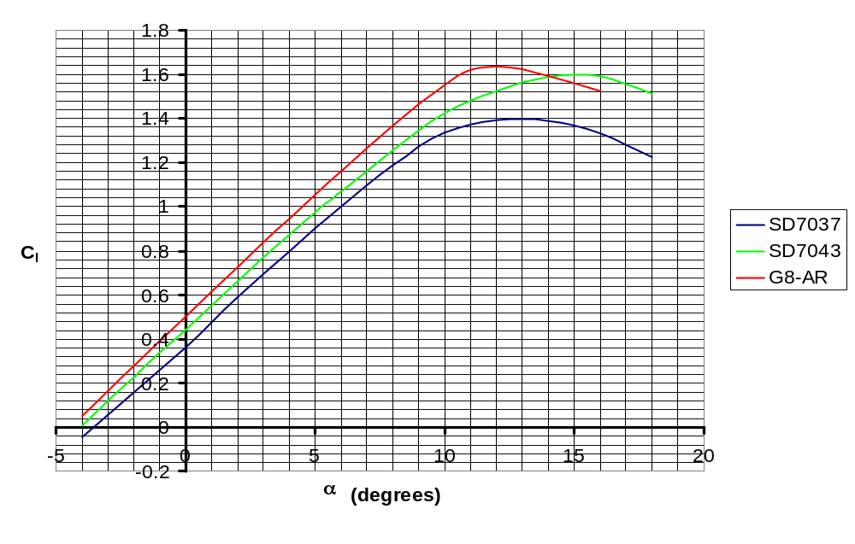
Figure 4-7 Lift versus Angle of Attack for Various Airfoils
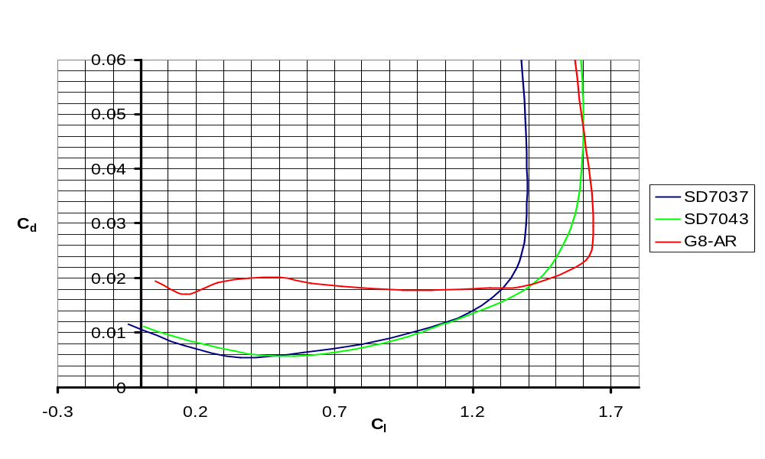
Figure 4-8 Drag versus Lift for Various Airfoils
Since a low drag airfoil was also a goal, the C_{d} vs. C_{l} curve for all three airfoils were evaluated. Both SD airfoils were relatively equal in drag, but the G8-AR had twice as much drag (see Figure 4-4). Although the G8-AR had more lift, high-speed demand of the competition led to the decision that this airfoil would not be used.
The choice was now between the SD7037 and the SD7043. To ensure the best turn and take-off performance, the airfoil with the highest C_{lmax} was chosen, SD7043. XFOIL was used to try to improve upon the airfoil, but this airfoil type was already at its peak performance, therefore it was maintained as the original.
Reading from Figure 4-3 and 4-4, minimum drag for the SD7043 is 0.055 at a C_{l} of 0.525. The respective angle of attack is approximately 1 degree. Design of the wing would ensure a provision for a 1-degree cruise angle of attack.

Planform Shape
Based on turn performance (4.5-g turn) and take-off distance (120 ft), required planform area was calculated to be 5.52 ft², turn performance being the limiting factor.
The RAC dictated the decisions on the planform shape. Every foot of wing span increases the RAC; therefore, the wingspan should be minimized. Minimizing the wing span increases chord size, which also increases the RAC, but not as much for a given area; Figure 4-5 illustrates this effect. Span can only be minimized to the point where the chord increases to 1 foot since anything larger would have trouble fitting in the required assembly box. A maximum root chord of 11 inches was chosen to reserve the ability to have some growth if necessary. Changing the taper ratio toward a more efficient (elliptical) planform shape would cause a significant increase in the RAC, as shown by the dashed curves in Figure 4-5. To minimize RAC, taper ratio was fixed at 1, resulting in a rectangular planform.
Increasing the Aspect Ratio (AR) to increase the lift slope of the wing was limited by the increased structural requirements and the increased RAC. Increasing AR would also decrease the drag of the wing, summarized in Table 4-1. Decreasing the AR would not only decrease the lift slope, but would result in the increasing of the chord size, causing a storage issue with the assembly box, as illustrated in Figure 4-6. Applying the range of appropriate aspect ratios from Figure 4-6 to the allowable chord sizes in Figure 4-5, the wing span becomes 6 ft, chord 0.92 ft, and AR 6.5. This allows for the minimum RAC while still accomplishing the mission.

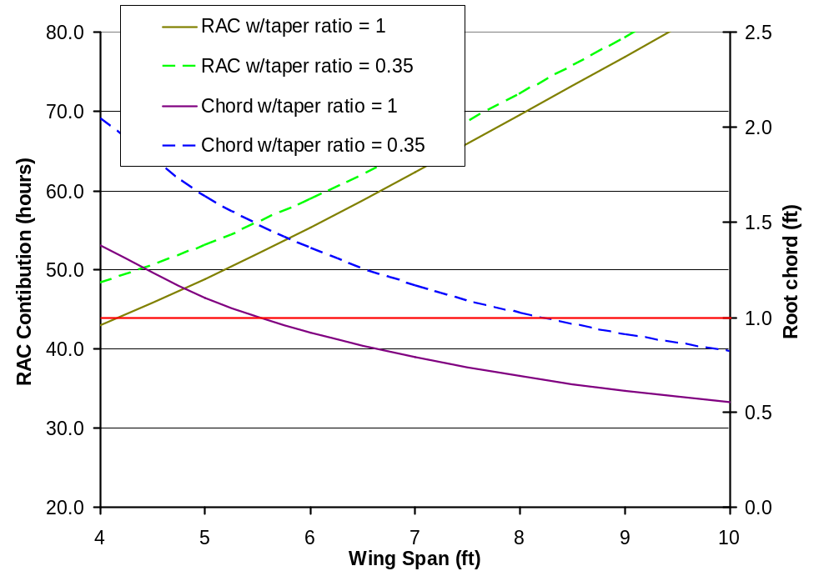
Maximum 1-foot chord due to box size
Figure 4-9 Rated Aircraft Cost Contribution from Wing Span

S | AR | b | c | c | b/2 | C_{D} | Drag | RAC
ft² |  | ft | ft | in | ft |  | lb
5.5 | 5.5 | 5.50 | 1.00 | 12.00 | 2.75 | 0.01252 | 0.729 | 52.00
5.5 | 6.0 | 5.74 | 0.96 | 11.49 | 2.87 | 0.01236 | 0.720 | 53.62
5.5 | 6.5 | 5.98 | 0.92 | 11.04 | 2.99 | 0.01215 | 0.708 | 55.19
5.5 | 7.0 | 6.20 | 0.89 | 10.64 | 3.10 | 0.01203 | 0.701 | 56.73
5.5 | 7.5 | 6.42 | 0.86 | 10.28 | 3.21 | 0.01186 | 0.690 | 58.23
5.5 | 8.0 | 6.63 | 0.83 | 9.95 | 3.32 | 0.01167 | 0.679 | 59.70
Table 4-13 Summary of AR Versus Drag and RAC
With an aspect ratio of 6.5, C_{L} will be lower than the C_{l} due to finite wing effects. Calculated C_{L} due to finite wing effects for various aspect ratios at 1º angle of attack are shown in Figure 4-7 below.

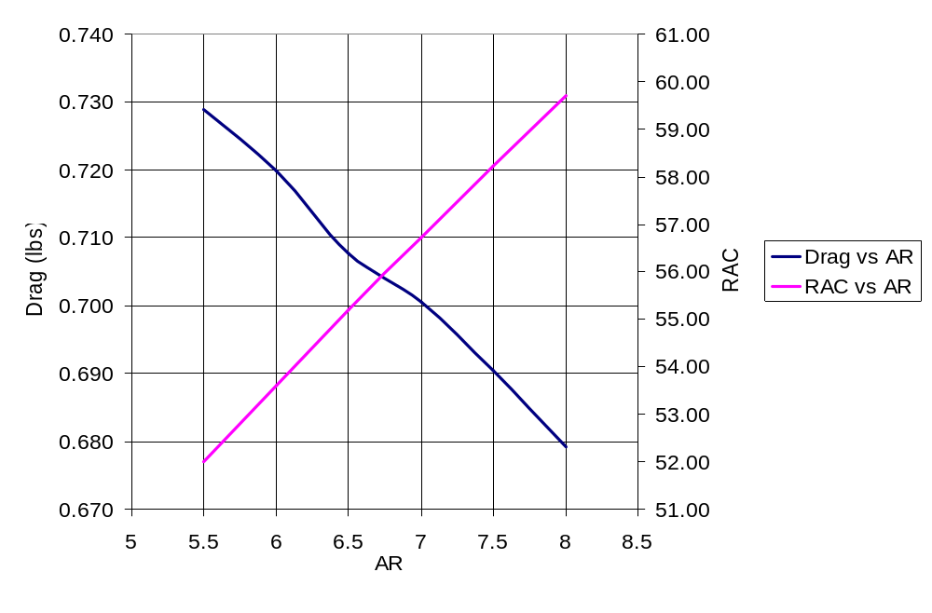
Limited by box size and high drag
High structural weight and high RAC
Figure 4-10 Drag and RAC Comparison with Aspect Ratio
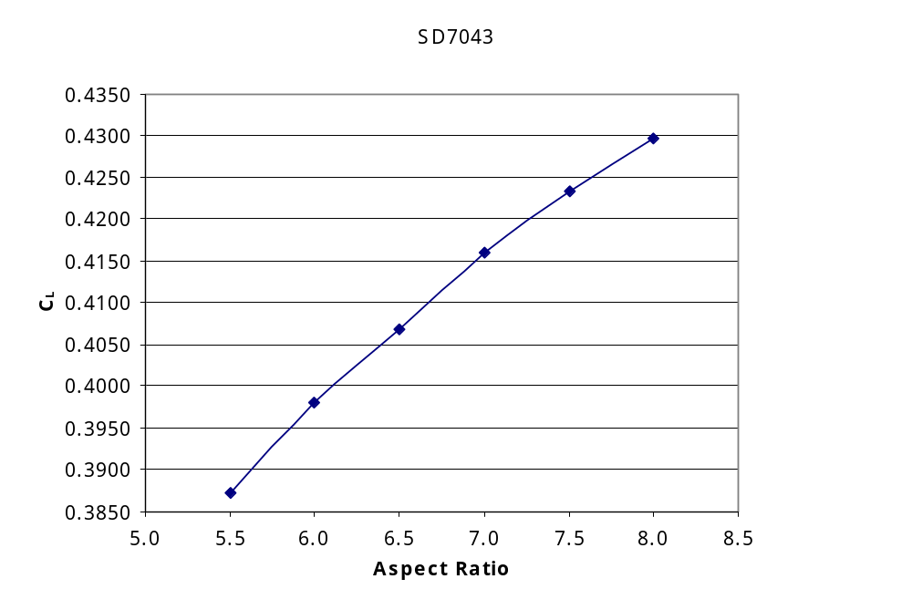
Figure 4-11 Lift Coefficients for Various Aspect Ratios at 1º alpha
Applying the same calculation for the entire lift curve results in Figure 4-8. C_{Lmax} and stall angle were calculated by methods in Reference 7.
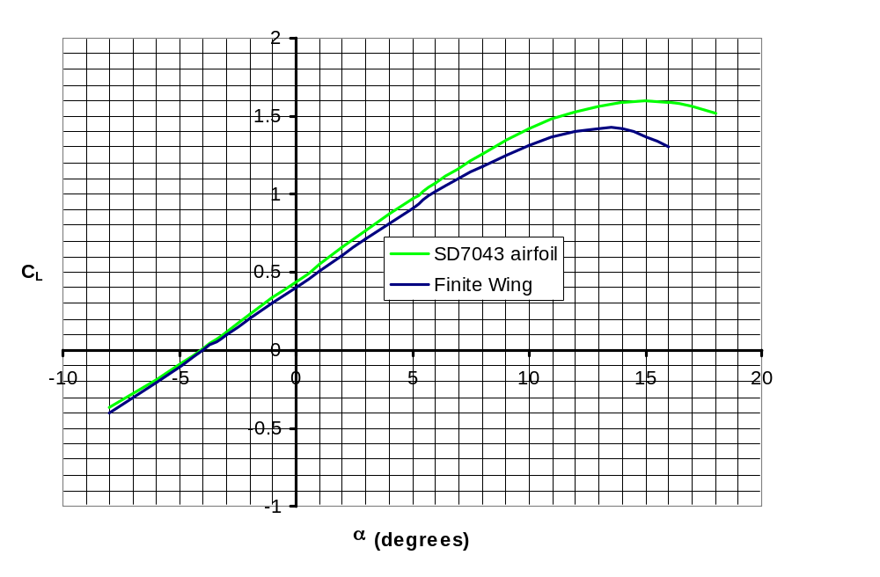
Figure 4-12 SD7043 Airfoil Compared to Finite Wing with an AR of 6.5

Wing Sizing Summary
- Rectangular planform
- Planform area 5.52 ft²
- Span 6 feet
- Chord 0.92 feet (constant)
- Aspect Ratio of 6.5

Fuselage
Weight savings had to be considered when evaluating the aerodynamic shape of the fuselage. The first step was to design an aerodynamic type shape around the payload box. A 2-D shape was drawn around the box payload. The points were then used as an input file for XFOIL. Using XFOIL, the shape of the pressure coefficient curve was modified to reduce drag to a minimum. The final shape is shown in Figure 4-9 below. By varying the angles of attack, drag was found to be minimum at 0 degrees.
The final points were then used to reproduce the shape in PRO-Engineer as a 3-D form. Two concepts were designed; one with a pointed trailing edge, and the other with a flat trailing edge (see Figure 4-10). The cross-sections were modified to minimize the size of the body and therefore reducing overall weight, but still able to carry the required payload.
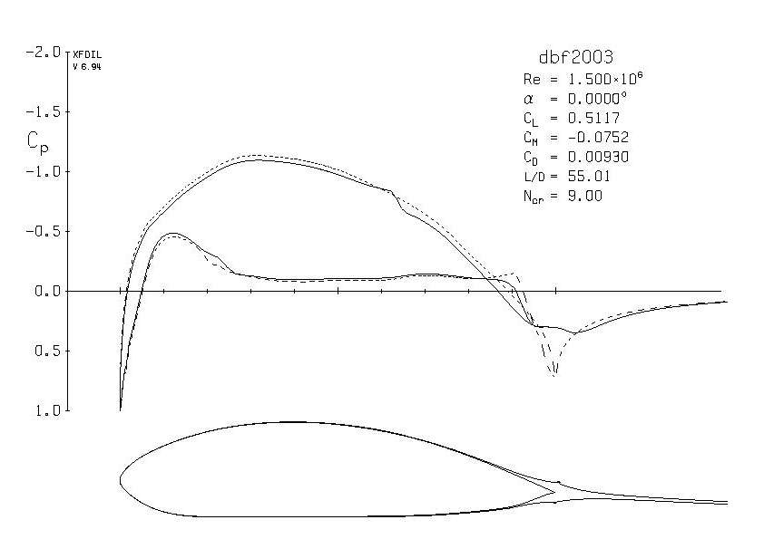
Figure 4-13 XFOIL Pressure Coefficient Diagram of Fuselage

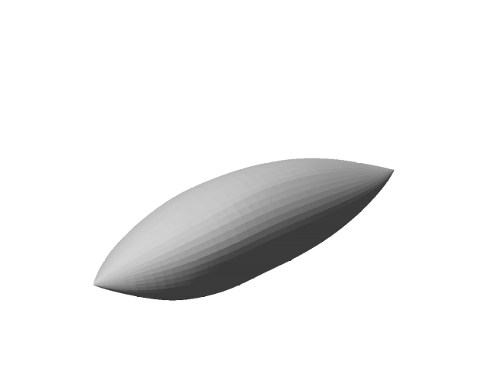 | 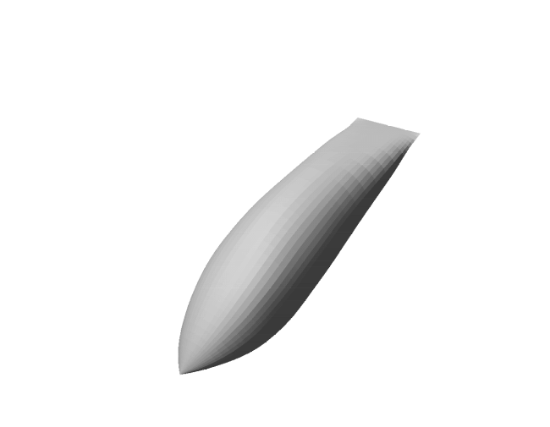
Figure 4-14 Fuselage Concepts

Comparison of the weights, as shown in Table 4-2 below, illustrates a significant difference between the flat trailing edge and the pointed trailing edge; there is a 10% weight savings with the pointed trailing edge. This result shows that the pointed trailing edge version has a significant advantage. Aerodynamic performance (lift, moments, and drag) was then evaluated to screen any advantage for the flat trailing edge. Weight was based on the assumption that the fuselage skin was the same carbon composite as last year’s competition entry.
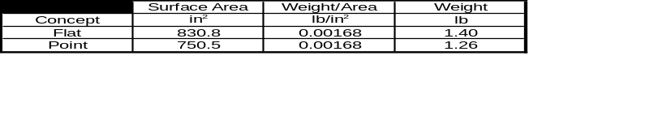
Table 4-14 Weight Comparison of Fuselage Concepts

Tail Options and Sizing
Tail design had to be evaluated through multiple considerations. First, the concept had to be evaluated by the RAC to determine its pre-sizing competitiveness. It also had to be evaluated for its simplicity to allow for a more rapid assembly time and a higher Total Flight Score. Lastly, it must provide for static and dynamic stability. RAC scoring does not directly penalize for the tail surface area unless its span is larger than ¼ span of the main wing. However, it does penalize for the overall length of the airplane; therefore, the length should be shortened while increasing the tail surface area. A further evaluation in the next section is aimed for sizing the tail to fit in the storage box, shortening the longitudinal length of the tail to minimize the RAC, but still maintaining stability.

T-tail
Using a T-tail is the most conventional approach. As discussed in the conceptual design, it has a lower RAC, but the highest Effective Score. The problem is that the vertical stabilizer may need to be assembled, reducing the Total Flight Score. If a quick assembly could be devised, or if the tail sizing shows that the tail will fit in the box without disassembly, then this type of tail will work. An advantage of this tail is that the pilot has experience flying T-tail aircrafts; also, the fabrication team preferred to have a T-tail. If there is no notable advantage found from the stability evaluation then the T-tail would be the best choice.
Horizontal tail span was set at 18 inches to keep it within ¼ of the main-wing span in order to take advantage of the lower RAC. By assuming a large tail volume ratio of 0.6, the resulting chord is 8 inches. The reason for the higher-than-normal tail volume was to overcome the moment of the cylinder payload. A tail this size would still fit in the assembly box (based on initial packing concepts).

Vertical tail sizing began with the 1-foot maximum dimension of the assembly box, resulting in a vertical ratio of 0.034. This is a reasonable ratio for this type of aircraft. Final vertical tail size has a root chord of 8 inches, tip chord of 6 inches, and a span of 9 inches.

V-tail
A V-tail configuration results in a lower RAC. It also simplifies the assembly phase, if sized correctly. The disadvantage is the loss of effective surface area, resulting in a larger tail. If the tail is too large it may cause the RAC to rise significantly and thereby negating the advantage of the V-tail. More evaluation had to be performed to determine the effectiveness of the concept.
Sizing of the V-tail used the combined planform areas of the T-tail. Angle of the V-tail was set at 110º. The size would allow it to fit in the assembly box without being disassembled.

VSAERO Configurations Tested
Both of the tail concepts, T-tail and V-tail, along with each of the fuselage concepts were evaluated in VSAERO to determine their effectiveness for static stability. Figure 4-11 shows each of the concepts evaluated, including an inverted T-tail. The inverted T-tail had been removed from consideration due to the concerns of wing and cylinder wakes.

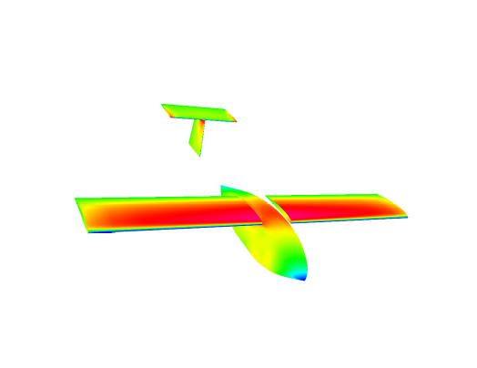 | 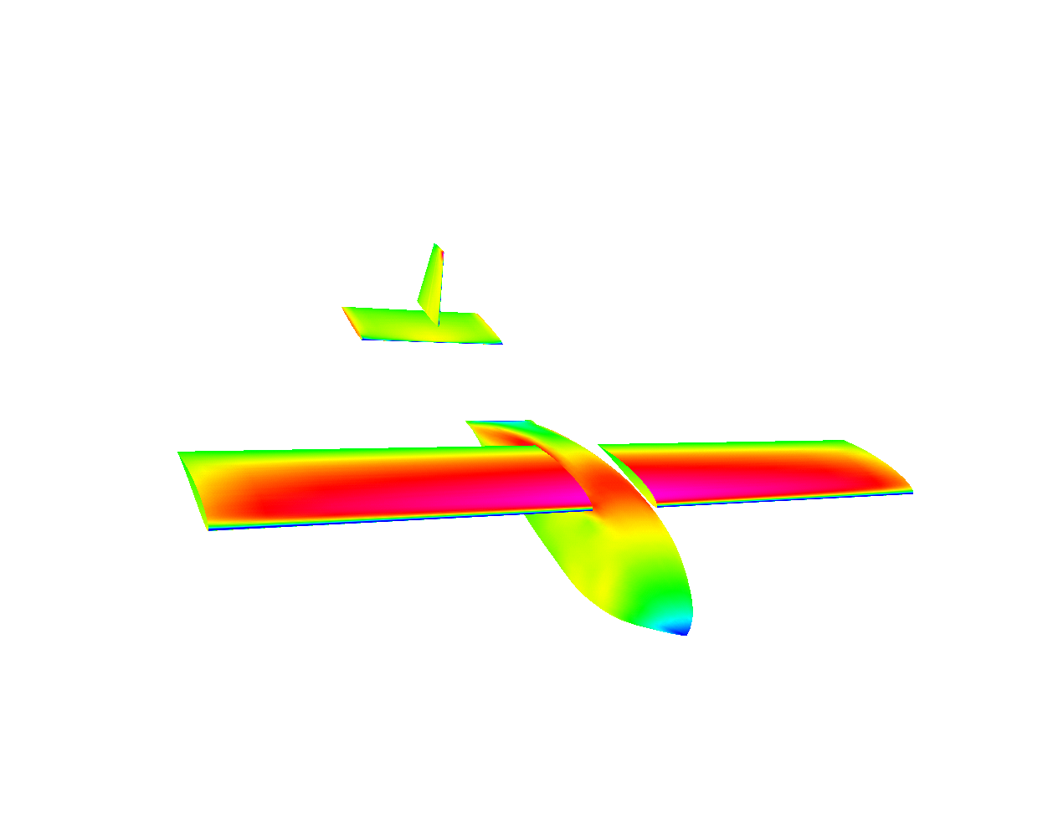
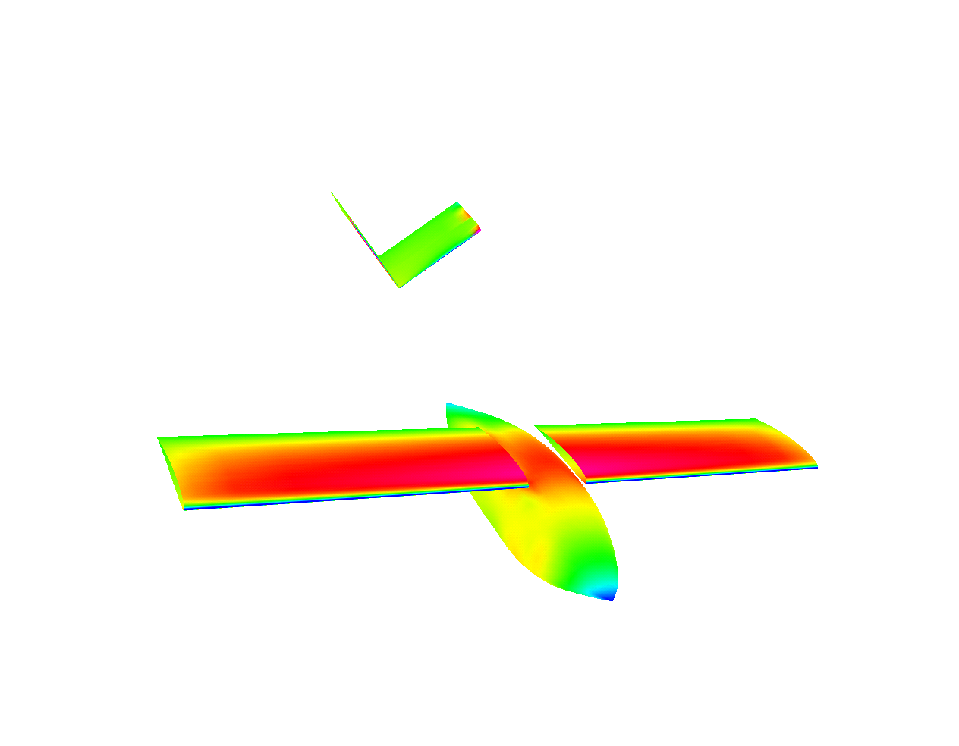 | 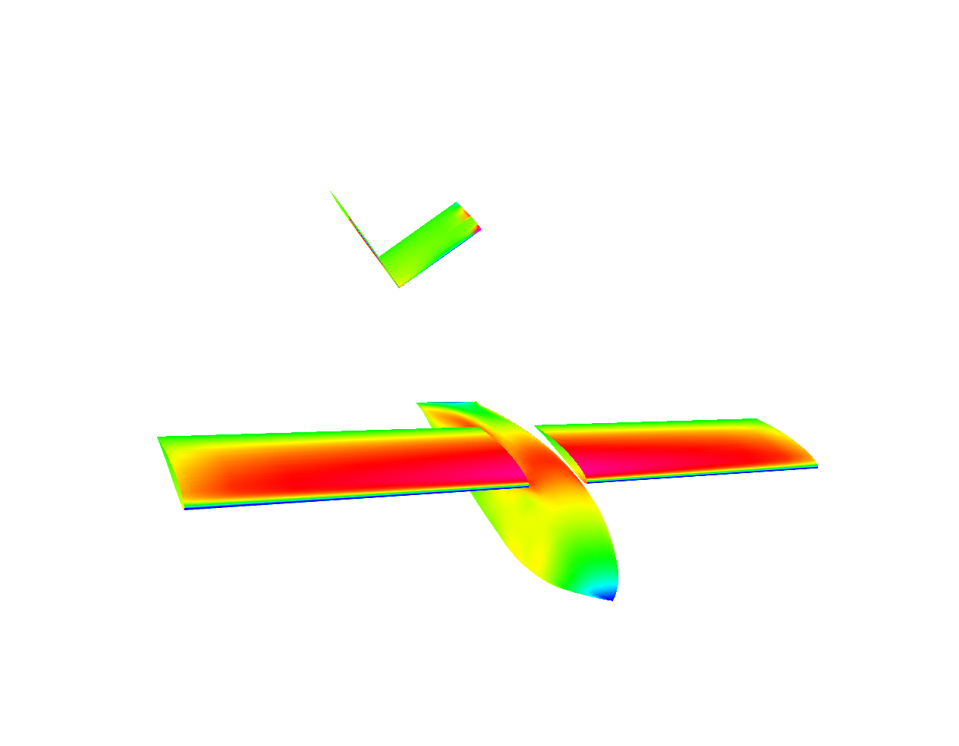
Figure 4-15 VSAERO models

Tail incidence angle optimization
To optimize the tail placement, its incidence angle first had to be found at various distances (as measured by l_{t}). Placing the body at its cruise angle, 0 degrees, and adjusting the tail incidence angle to achieve a C_{M} of zero, optimum tail incidence angles were found. This was done to minimize the trim drag during level flight, because last year’s airplane suffered from an extreme amount of trim drag. Figure 4-12 was produced using data from VSAERO; it is a summary of tail incidence angles. Once dynamic stability is complete as a function of l_{t}, the length of the airplane can be reduced to a minimum, then the tail incidence angle (i_{t}) can be set to the minimum trim drag angle.

Fuselage Static Stability Comparison
Placing the tail at the minimum trim drag incidence angle, static stability was evaluated for each of the concepts. First, the fuselage concepts were compared to see if any static stability advantage is gained from the different trailing edges. The comparison presented a negligible advantage as shown in Figure 4-13. Each concept demonstrated a positive C_{Mo} with a negative C_{Mα} slope, requirements for static stability.
Each tail and fuselage concept was then evaluated to obtain the static margin (K_{n}); static margin ranged from 0.20 to 0.50. The data shows the expected trend, as I_{t} increases so does static margin. Slightly higher static margins were achieved by the lifting-tail fuselage concepts.
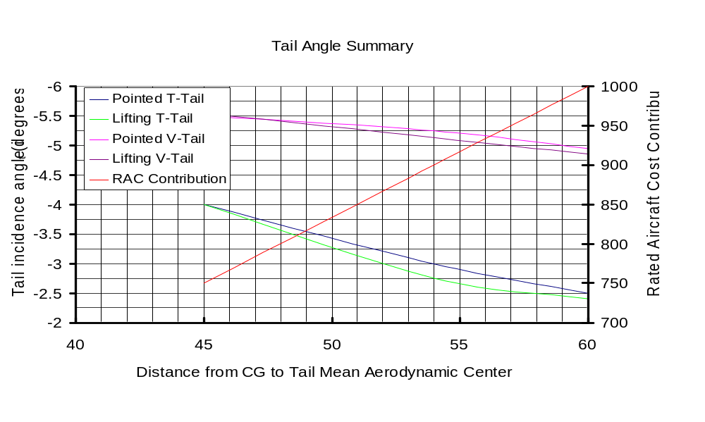
Figure 4-16 Tail Angle Summary

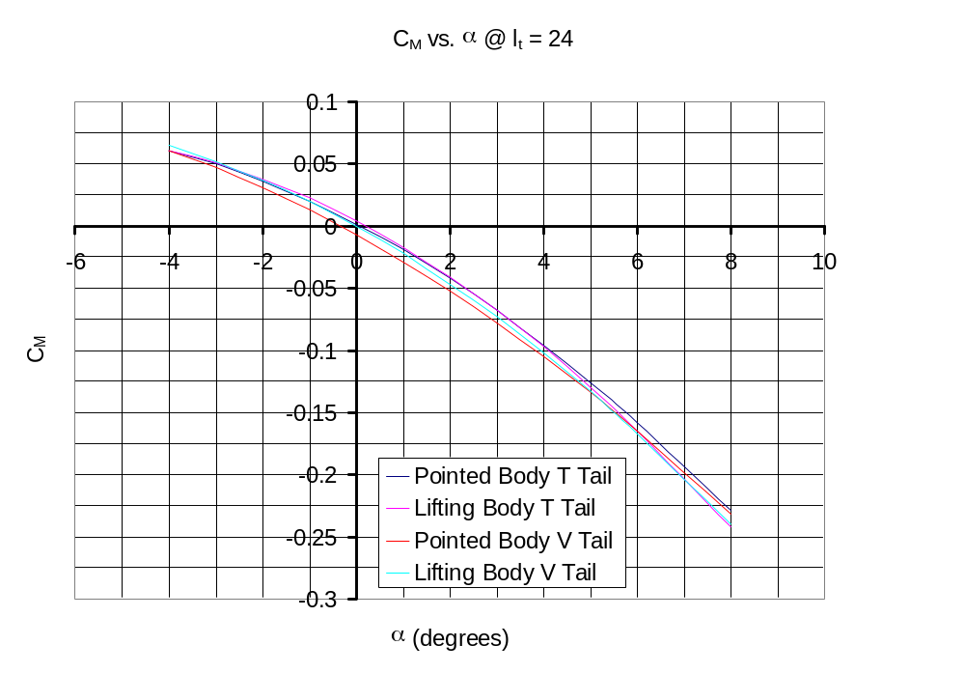
C_{Mo}
Figure 4-17 Static Stability of Fuselage Concepts

Tail and Fuselage Conclusion
There was little advantage in stability or lift of the flat trailing edge fuselage over the pointed fuselage. Choosing the pointed fuselage as the final design was due to the fact there was a significant weight savings. The V-tail provided no significant advantage and therefore was dismissed.

Wing-Body Lift Curve
VSAERO was used to find the wing-body lift curve for the final configuration. C_{Lmax} and α_{stall} was determined by the methods of reference 7. The curve did not change significantly from the finite wing curve in Figure 4-8 and therefore is not reproduced here.

Drag Estimation
Breaking the final configuration down into four component parts, namely the wing, fuselage, empennage, and landing gear, C_{Do} was calculated by the methods in Reference 8. The results are as follows:
C_{Do} = | C_{Do (wing)} | +C_{Do (fuselage)} | +C_{Do (empennage)} | +C_{Do (gear)}
0.0253849 | 0.01578482 | 0.006471667 | 0.003092458 | 3.5952E-05
Table 4-15 C_{Do} results
Applying the C_{Do} to the 3-term drag polar equation results in Figure 4-14 below.
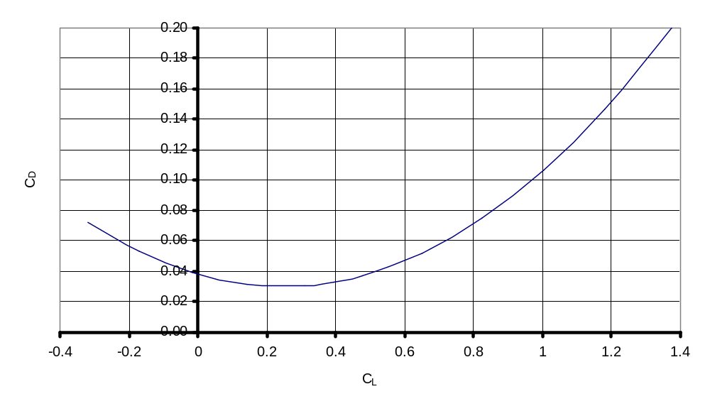
Figure 4-18 Three-Term Drag Polar

Power Plant Design
Initial investigations suggested that the Graupner Ultra 3300-10 motor would give better performance than the Astro 60, which had been used for last year’s design. The Graupner motor was purchased and tested against the Astro, and the Graupner showed a higher efficiency.
Computer simulation using P-Calc and MotoCalc suggested that maximum performance with the 10-turn Ultra 3300 would be obtained from high voltage battery packs with more than 28 cells. In order to investigate lower voltage (lighter weight) systems, the 3300-7 motor was selected. The results from calculations suggested that maximum performance would be obtained from approximately 22 cells. Further calculations predicted that the 3300-5 motor would yield even higher thrust and pitch speed than the 3300-7 on as few as 18 cells. In order to allow for some flexibility in the power system, both the 7-turn and 5-turn Graupner Ultra 3300 motors were purchased.
MotoCalc and P-Calc were used to model the power systems using a number of propeller sizes. The resulting parameters of major interest were a predicted thrust and pitch speed. While the 18x16 propeller was near optimum for the 3300-7, a smaller propeller of 15x16 yielded even more encouraging results for the 3300-5. The 3300-7/18x16 combination yielded 102.7 oz of in-flight thrust, with a pitch speed of 74.6 MPH. The 3300-5/15x16 gave only 68.2 oz of in-flight thrust, but at a pitch speed of 87.6 MPH.
Total battery weight is a very significant factor in the payload carrying ability of any aircraft; therefore, the decision was to keep battery weight to the minimum required to complete the flight missions. Minimizing the battery weight also reduces the RAC considerably. Because the 24% higher in-flight thrust of the 22-cell 3300-7 power system required a 50% increase in battery weight, the 18-cell 3300-5 system was chosen for initial flight testing. For enough duration to finish one mission the Sanyo CP-2400 was chosen.
In conclusion the initial power system is as follows: Graupner Ultra 3300-5 motor, Kruse 2:1 gearing, RFM 15x16 propeller, 18 Sanyo CP-2400 cells, SWN Super 120 speed controller.

Structural Considerations
Conceptual Design defined a requirement such that the aircraft must be able to sustain a 4.5-g turn. Landing may also cause high loading due to rough conditions. To ensure structural integrity, a skeletal structure was designed with proper load paths between the wings, motor, tail boom, and landing gear. A model was created in Pro-Engineer and evaluated with Pro-Mechanica. Any high stress areas, which were marginal, were redesigned to reduce these stresses.
Although there was a major concern for the wing base, results showed no significant structural problems in this area. Since the fuselage skin is a carbon fiber composite, it will provide enough extra strength to accommodate the high stress areas shown in Figure 4-15 below.
The split-wing interface loading was calculated to have a bending moment of 600 in-lbs at a 4.5-g turn. This translates to a bending stress of about 50,000 psi using a ½ in. solid-carbon rod, which can take four times that amount (safety margin of 4).
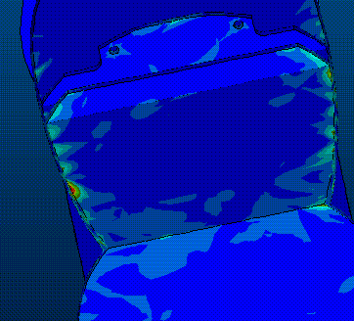
High stress area
High stress area
High stress area
Figure 4-19 Pro-Mechanica Structural Analysis

Detailed Design
The detail design was the final step before fabrication could begin. Drawings were created and performance was estimated.

Configuration Summary
The following table contains all the configuration data as required by the report. Performance was calculated using the methods in Reference 7.
Geometry |  | Performance
Length | 4.5 ft | C_{Lmax} | 1.41
Wing span | 6 ft | L/D _{max} | 11.0
Height | 1.7 ft | Maximum rate of climb | 15 ft/s
Wing: root chord | 0.92 ft | Stall speed | 44.2 ft/s
Wing: tip chord | 0.92 ft | Maximum Speed | 118 ft/s
Wing area | 5.52 ft² | Take off field length (empty) | 50.6 ft
Aspect Ratio | 6.5 | Take off field length (gross) | 119 ft
Horizontal area | 1 ft² | Systems
Horizontal volume ratio | 0.58 | Radio | Hitec Prizm 7X
Vertical area | 0.44 ft² | Servos | Hitec HS-225BB
Vertical volume ratio | 0.034 | Battery | 18 Sanyo CP-2400
Weight Statement (lb) |  | Motor | Graupner 3300-5
Airframe | 7 | Propeller | 15x16 RFM
Propulsion | 4 | Gear Ratio | 2 to 1
Control System | 0.5
Payload System | 0.2
Payload | 6
Empty Weight | 11.7
Gross weight | 17.7
Table 5-16 Final Component Selection, Geometry, Performance, Weight Statement, and Systems

Rated Aircraft Cost
Final RAC is 7.81, based on the following table.

 | RAC | 7.81
 | MEW | 11.7
 | REP | 2.34
 | MFHR | 156.36
# of cells | 18 |  | Sanyo 2400
weight per cell | 2.08 | oz | weight includes extra hardware
total battery weight | 2.34 | lb
WBS | Value | Hours | Multiplier
1.0 Wings
wing span (ft) | 6.00 | 48 | 8 hr/ft Wing Span
chord (ft) | 0.92 | 7.36 | 8 hr/ft Max chord
# of control surf | 2 | 6 | 3 hr/control surface
2.0 Fuselage
Max length (ft) | 4.5 | 45 | 10 hr/ft max length
3.0 Empennage
# of vertical-nc | 1 | 5 | 5hr/vertical-no control
# of vertical-ac | 0 | 0 | 10 hr/vertical-active control
# of horizontal | 1 | 10 | 10 hr/horizontal-see wing rule
V-tail only |  | 0 | v-tail-15 hr
4.0 Flight Systems
# of servos/control | 5 | 25 | 5 hr/servo (Note 1)
5.0 Propulsion
#of engines | 1 | 5 | 5 hr/engine
#of propellers | 1 | 5 | 5 hr/propeller
Note 1: 2 ailerons, 1 elevator, 1 nose wheel, 1 payload release (no rudder)
Table 5-17 Rated Aircraft Cost of Final Configuration

Dynamic Stability Estimation
Section 4.6 showed that the airplane would be statically stable, but dynamic stability still had to be confirmed. A combination of sources was used to accomplish this task. Pro-Engineer provided the moments of inertia, Advanced Aircraft Analysis (AAA) supplied some information, and the rest was hand calculated using References 4, 7, and 8. The derivatives had to be performed for the vehicle’s stabilities in the longitudinal and lateral directions.
Based on an average speed of 100 ft/s the phugoid period is 13.8 seconds, which is enough time for the pilot to make corrections.

Longitudinal and lateral stability derivatives are as follows:
Conditions |  |  | Longitudinal |  | Lateral
θ_{o} | 0 | (degrees) | C_{Xu} | -0.1 | C_{yβ} | -0.3826
g | 32.2 | (ft./sec.²) | C_{Zu} | -0.1 | C_{yp} | 0.0015
M | 0.09 | (Mach #) | C_{Mu} | 0.0015 | C_{yr} | 0.0846
W | 18 | (lbs.) | C_{Xα} | 0.2 | C_{lβ} | 0.0800
I_{y} | 771 | (slug*ft.²) | C_{Zα} | -5.76 | C_{lp} | -0.4680
alt | 100 | (ft.) | C_{Mα} | -0.7953 | C_{lr} | 0.3886
a(h) | 1117 | (ft./sec.) | C_{Xq} | 0 | C_{nβ} | -0.1059
ρ | 0.00237 | (lbs.*sec.²/ft.⁴) | C_{Zq} | -6.63 | C_{np} | -0.1451
S_{w} | 5.52 | (ft.²) | C_{Mq} | -10.76 | C_{nr} | -0.0863
c_{bar w} | 0.92 | (ft.) | C_{Xα}^{dot} | 0
 |  |  | C_{Zα}^{dot} | -2.056
 |  |  | C_{Mα}^{dot} | -3.27
Table 5-18 Stability Derivatives
Using the characteristic equation coefficients and Routh’s criteria for stability, the aircraft has no unstable modes for this flight condition. An evaluation was performed for takeoff, landing, and different load conditions and no stability problems were found.

Manufacturing Plan
Evaluating all the major components with respect to the choices of the materials resulted in choices of fabrication methods. Each process was rated on a number scale in which high numbers were desirable characteristics and low numbers were undesirable characteristics. After the evaluation a manufacturing schedule was created.

Major Components
Major components were defined as the parts of the aircraft that needed to be fabricated before the propulsion system, assembly systems, and electronic components were installed. The major components were the fuselage, wings, tail, bulkheads, tail boom, motor mount, nose/ main landing gear, and wheels. They also included the interfacing mechanisms with each other. Other parts such as assembly systems were produced in parallel with the major components.

Materials
Materials that were considered for the major components included carbon fiber, fiberglass, plywood, aluminum, and plastic, and one other commercially available material (steel) in a pre-manufactured form for the nose gear. The materials were rated for each component by using Figures of Merit (FOM). Minor components were made either of the above materials or of brass, Kevlar composite, or balsawood. Because minor components required less lead-time, they were fabricated in various ways and allowed choices to be made based on the component performance.

Figures of Merit
Figures of Merit (FOM) were used to evaluate the materials for the availability, required skill levels, cost, time to manufacture, and strength to weight ratio.

Availability
Scaling ranged from 0 to 2. If the materials or the components were on hand, it received a 2. If they had to be purchased or they required machining, it received a 1. If the material was not available due to reasons beyond the team’s control, it received a 0.

Required Skill Levels
Easy to fabricate materials, which required no previous or limited experience, were issued 5 points. A prohibitively difficult process or an unavailability of the manufacturing equipment received a 1. Skills of the team members were also used in order to make an informed decision about the manufacturing process within each of the categories. Table 6-1 is a summary of number of personnel with the appropriate skills.
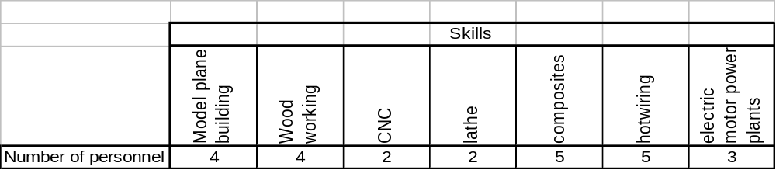
Table 6-19 Skills Matrix

Cost
A value of 1 was assigned if the cost of the material was beyond the means of the project’s budget. Inexpensive material received a 5. If the material was already on hand or if it was to be donated in sufficient amount, it was given a rating of 5; carbon fiber and fiberglass were in that category.

Time to Manufacture
This parameter was added as a FOM because the team needed to fabricate the major components in time for flight-testing. Composite materials received the low rating of 1 because the team had to fabricate bulkheads and cut them to size. Material or components available in their final form received the high rating of 3.

Strength to Weight Ratio
A qualitative approach was taken to determine the strength to weight ratio for each material since many of the materials such as some of the carbon fiber fabrication techniques are not readily calculated. Experience and experimental techniques were used to determine the capability of the material properties.

Summary of Material Choices
Table 6-2 shows the evaluation of the materials for different components of the aircraft. Highlighted numbers are the highest scoring material and therefore chosen for the fabrication method for the specified component. Most components would be fabricated using a carbon fiber composite with only a few exceptions. The motor mount plate is to be made of aluminum and both the wheels and nose gear were obtained commercially; modifications were made to optimize the commercial products to fit the design.

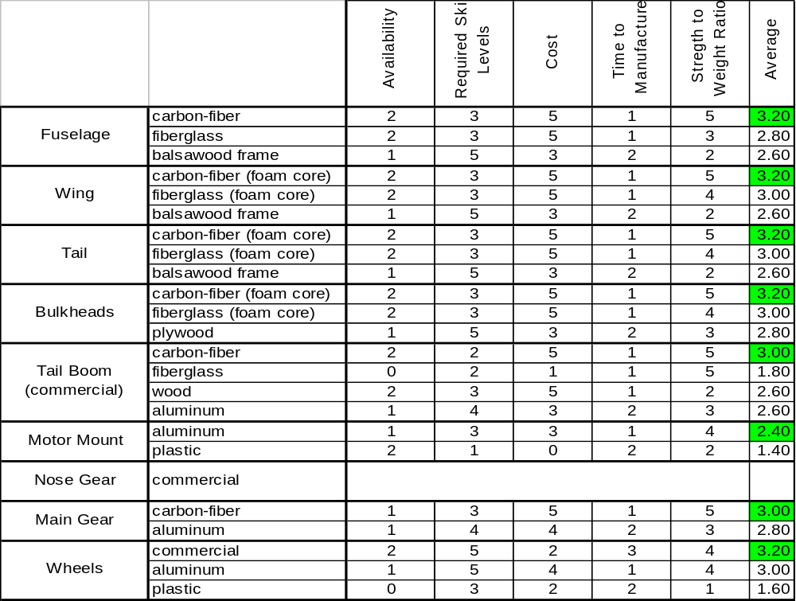
Table 6-20 Figures of Merit Summary for the Manufacturing Process

Manufacturing Schedule
The manufacturing team leader created the schedule to complete fabrication and test fly a prototype before the report was due. Both projected and actual schedules are shown in Figure 6-1 below.

Manufacturing Processes
Fabrication sites were at the Aerospace Lab at San Diego State University and at the shop of the Manufacturing Team Leader. Safety during the manufacturing processes was maintained by following the team leader’s instructions.
Choices of the materials led to a definitive process of fabrication for each component. Alternative processes investigated were to use a foam core or a female mold for the fuselage fabrication. These two processes were evaluated with respect to the following FOM:
- Time to Manufacture: With the projected date of the flight-testing approaching, this was the most significant of any other factors; the foam core required less time to manufacture.
- Expected Product Performance: The foam core would create a rougher finish on the outer surface of the composite skin. Female molds could be smoothened out to reproduce a close shape to the drawings.
- Required Skill Level: Team lacked the experience in manufacturing the molds.
- Cost: The foam was considerably less expensive than the materials required for making the molds.
- Repeatability: A high repeatability would ensure easy reproduction in case of failure in fabrication or damaged to the finished product. The use of foam core is an irreversible process, whereas the female molds could be used repeatedly.
The alternative with an advantage in each FOM was awarded a 1. Summation of the points led the decision to use the foam core. This evaluation is summarized in Table 6.3 below.
 | Time to Manufacture | Expected Product Performance | Required Skill Level | Cost | Repeatability
 |  |  |  |  |  | Sum
Foam Core | 1 | - | 1 | 1 | - | 3
Female Molds | - | 1 | - | - | 1 | 2
Table 6-21 FOM Summation for Fuselage Manufacturing Technique

The following describes the processes of the major component fabrication. Pictures of some of the manufacturing processes are shown in Figure 6-1 below. The processes for each component are chronologically ordered.

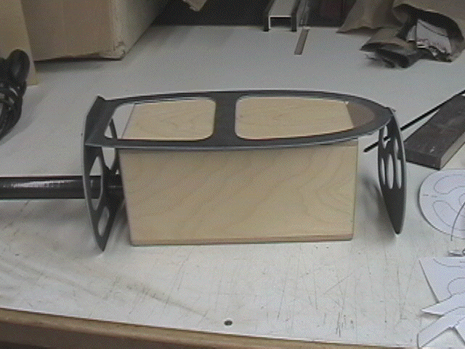 | 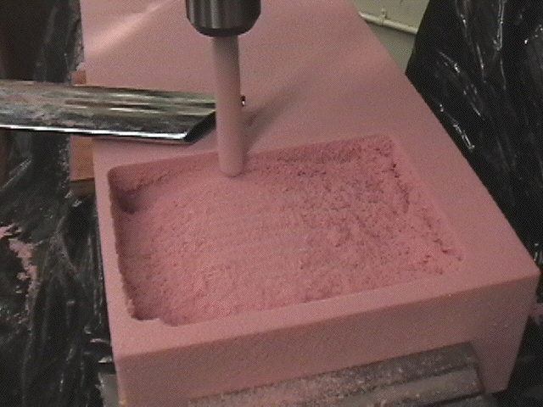
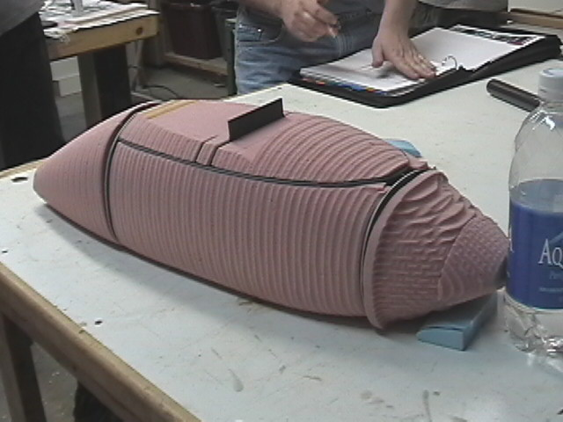 | 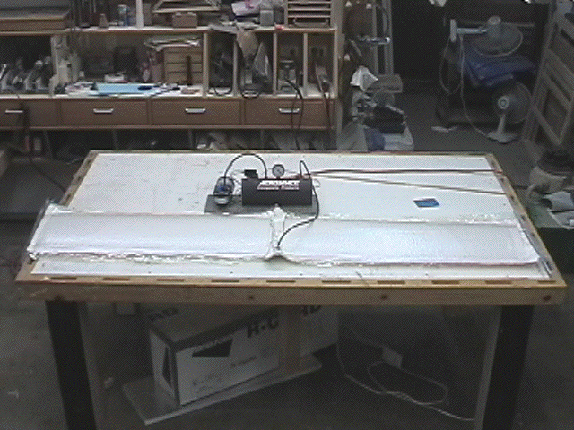
Figure 6-20 Manufacturing processes used (clockwise from upper left: basic internal structure with payload, CNC milling, vacuum bagged wings, foam core prior to sanding)

Structural Framework
Structure framework was first created using carbon fiber/foam sandwich composite sheets. Other parts such as the motor mount bulkhead used a multiple layer of carbon composite including Kevlar. Templates were used to cut the bulkheads to size.

Fuselage
Codes (m-code) were obtained from Pro-Engineer (CAD) of the fuselage outer-mold-line (OML) and then transferred to the CNC for an autonomous milling of the foam core. The foam core was combined with the bulkheads and finished sanded to a smooth surface. Lay-up consisted of carbon fiber and epoxy, using a flexible vacuum bag. Upon curing, the foam was removed and interface areas prepped for the final assembly.

Wings and Tail
The first step was to hotwire the foam cores by using a fabricated endplate template. To obtain a smooth finish and accurate sizing carbon fiber and epoxy lay-up was used along with a vacuum bag and Mylar sheets.

Main Landing Gear
Landing gear shape was designed using Pro-Engineer. The drawing was used as a template to create a wood mold. Landing gear was then fabricated in the same multi-layered method as the motor mount bulkhead.

Nose Gear
A commercially obtained nose wheel had to be modified for the assembly system. The upper shaft was cut and threaded to accept the hinged adapter. The hinged adapter was designed and then machined in the school’s lab by the manufacturing team.

Motor Mount
An adapter plate between the reduction gear and the motor was substituted for a motor mount plate designed and machined by the manufacturing team. It was needed to interface the motor to the motor mount bulkhead.

Tail Boom
A wrapped carbon fiber tube was obtained for the tail boom. Because of the expense of the tail boom, a lightweight aluminum was purchased as a standby.

Electronic Components and Payload Deployment System
The final steps of the fabrication were the installation of electronic components and the payload deployment system. Electronic components, namely wires and servos, were installed in such a way that they would require the shortest length of the connections while reducing the possibility of failure. The payload release system was then placed into the structure. Finally, the fuse was mounted on a relatively flat surface on the side of the fuselage.

Structural Integrity
Dropping the body with a 15 lb load from one-foot high tested the landing gear interface. The load simulated a rough landing during the actual missions; the test was conducted more than 10 times. Although a large amount of flex occurred on the main gear, the structure did sustain the load.
Based on wing loading during a 4.5-g turn, the wings were tested to ensure they could handle the load. Wings were assembled to the body and an extra 45 lb box payload was hung from the CG. The wings were then lifted from 1/4 span to test the wing body interface; the test was successful.

Conclusion of Fabrication Phase
Installation of the electronic components and payload deployment system marked the end of the fabrication phase. The propulsion system, namely the motor and the batteries, would be placed into the reserved spaces without affecting the structure. Now the Spirit of Monty was ready for the flight-testing.

Testing Plan
Completion of the fabrication phase was in time for flight-testing on March 9, 2003 at Lakeside, California.

Flight Testing Objectives and Checklist
The objectives were set to simulate the competition, to evaluate the general performance of the prototype, and to obtain information for optimization. Simulation of the competition would be achieved by conducting a safety inspection and by attempting the three mission flights. A completed checklist for first-flight is shown in Table 7-1 below. Results of the testing and lessons learned are described in Section 7.2.

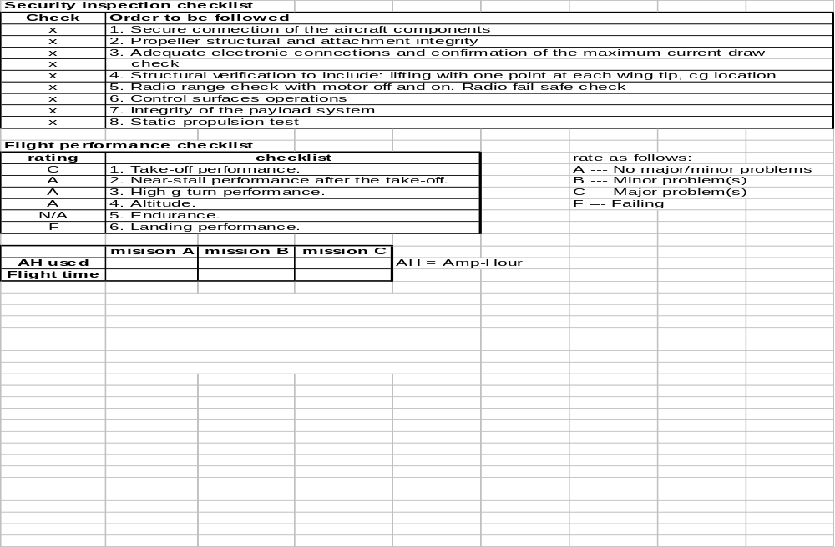
Table 7-22 Testing Worksheet

Lessons Learned
Testing began in the late afternoon. As Table 7-1 indicates, the security inspection was completed without problems. However, the flight was limited for one lap without payload, due to the sunset; the aircraft made its first flight with glow-lights attached. The measured take-off distance was approximately 110ft. Time of flight, including the times of take-off and landing, was 44 seconds. The aircraft stumbled and flipped up side down at the end of the landing. The payload box was not installed. Power usage was not measured.
Although the flight was brief, the post-testing conference addressed some key issues in power plant, control surfaces, and landing gear performances. According to these results, recommendations were made for modifications and further optimizations.

Power Plant
A considerably longer take-off distance, compared to the estimated distance in the detail design, indicated that the aircraft was underpowered. The analyses of the combination of the propeller and battery, or the pitch of the propeller, should be reviewed. In the analyses, effects on static performance may need to be emphasized against dynamic performance, so that the take-off thrust is sufficient. Power plant was expected to be a limiting factor since the configuration was the minimum required, which saved on RAC. Steps will be done to try to improve this power plant while marinating a low RAC.

Control Surfaces
The landing-run required more than 200ft, at the end of which the aircraft lost control. This was due to a lack of yaw control, as the pilot alluded to in the conference. The aileron-only-landing provided less than necessary control than expected. A provision was already included into the vertical stabilizer to add a rudder if needed. Although the extra servo will increase the RAC, the team wanted to first attempt flight without it. In addition, the sensitivity or the effect of the elevator was observed to be too profound. Adjustment on the transmitter can be done to accommodate this for the next flight.

Landing Gear
The aircraft was observed to tend sideways during the take-off and landing. Insufficient rigidity of the nose gear and/or main gear could cause this issue. The aluminum socket for the nose gear was spotted as one of the possible causes; a modification will be made on the joint. Also, the placement of the nose gear with respect to the servo structure may need to be assessed whether it was aligned to the direction of take-off with the controller deactivated.

References
- Abbott and A.E. Von Doenhoff. Theory of Wing Sections, New York: Dover, 1959
- Anderson, John. Fundamentals of Aerodynamics. New York: McGraw-Hill, 1991
- Drela, Mark. XFOIL 6.94 User Guide. Boston: MIT, 1986
- Etkin, Bernard. Dynamics of Flight. New York: John Wiley & Sons, 1996.
- Katz, Joseph, and Allen Plotkin. Low Speed Aerodynamics. New York: Cambridge, 2001
- Nathman, James. VSAERO User’s Manual Version 6.2. Redmond: Analytics Methods Inc., 1982
- Nicolai, Leland. Fundamentals of Aircraft Design. San Jose: Mets, 1984.
- Roskam, Jan. Airplane Design: Part VI. Lawrence: DARcorporation, 2000.

WBS is the Work Breakdown Structure. The summation of the WBS is equivalent to the Manufacturing Man Hours

